public class HelloWorld {

public static void main(String[] args) {

System.out.println("Hello World!");

}

}

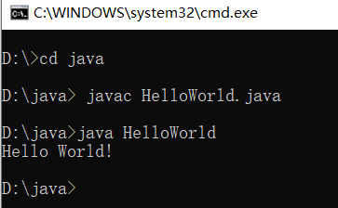

两只老虎，一只重180KG，另一只重200KG，判断体重是否相等

public class nimade {

public static void main(String[] args) {

int weight1 = 180;

int weight2 = 200;

boolean b= weight1 == weight2? true : false ;

System.out.println(b);

}

}

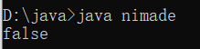

**三个和尚，150cm，165cm，210cm，找最高的**

public class nimade {

public static void main(String[] args) {

int height1 = 155;

int height2 = 165;

int height3 = 210;

int tempheight = height1 > height2? height1 : height2;

int height = tempheight > height3? tempheight : height3;

System.out.println(height);

}

}

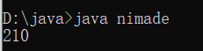

**数据输入，①导包②创建对象③接收数据**

import java.util.Scanner;

public class nimade {

public static void main(String[] args) {

Scanner sc = new Scanner (System.in);

int x =sc.nextInt();

System.out.println("x:"+x);

}

}

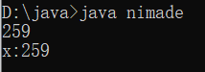

**三个和尚升级版，键盘输入三个和尚的身高然后找到最高的**

import java.util.Scanner;

public class nimade {

public static void main(String[] args) {

Scanner sc = new Scanner (System.in);

System.out.println("请输入第一个和尚的身高:");

int height1 =sc.nextInt();

System.out.println("请输入第二个和尚的身高:");

int height2 =sc.nextInt();

System.out.println("请输入第三个和尚的身高:");

int height3 =sc.nextInt();

int tempheight = height1 > height2? height1 : height2;

int height = tempheight > height3? tempheight : height3;

System.out.println(height+"cm");

}

}

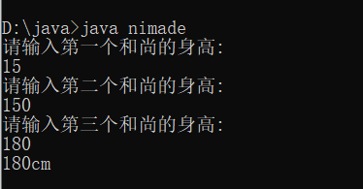

遇到的问题：cmd乱码

解决方法：用-encoding指令来为文件指定编码格式。

例如 javac -encoding UTF-8 XXX.java

**If...else结构**

public class nimade {

public static void main(String[] args) {

int height1 = 100 ;

int height2 = 200 ;

if (height1==height2) {

System.out.println("相等");

} else {

System.out.println("不相等");

}

}

}

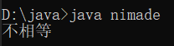

奇偶数，输入一个数字，判断奇偶

import java.util.Scanner;

public class nimade {

public static void main(String[] args) {

Scanner sc = new Scanner (System.in);

System.out.println("请输入一个数字");

int a =sc.nextInt();

if (a%2==0) {

System.out.println(a+"是偶数");

} else {

System.out.println(a+"是奇数");

}

}

}

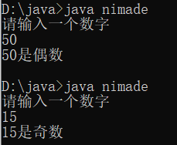

**If...else...if结构**

键盘输入一个星期数，判断星期几

import java.util.Scanner;

public class nimade {

public static void main(String[] args) {

Scanner sc = new Scanner (System.in);

System.out.println("请输入一个星期数");

int week =sc.nextInt();

if (week == 1) {

System.out.println("星期一");

} else if (week == 2){

System.out.println("星期二");

} else if (week == 3){

System.out.println("星期三");

} else if (week == 4){

System.out.println("星期四");

} else if (week == 5){

System.out.println("星期五");

} else if (week == 6){

System.out.println("星期六");

} else if (week == 7){

System.out.println("星期日");

}

System.out.println("结束");

}

}

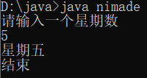

**考试奖励**

import java.util.Scanner;

public class nimade {

public static void main(String[] args) {

Scanner sc = new Scanner (System.in);

System.out.println("请输入分数数");

int score =sc.nextInt();

if (score > 100 || score < 0 ) {

System.out.println("输入有误");

} else if (score >= 95 && score <= 100 ) {

System.out.println("iphone13");

} else if (score >= 90 && score <= 94){

System.out.println("air pods 3");

} else if (score >= 80 && score <= 89){

System.out.println("Aj 13");

} else {

System.out.println("寄！");

}

System.out.println("结束");

}

}

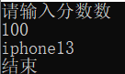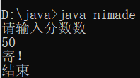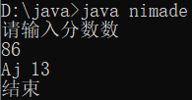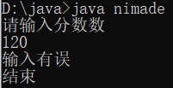

**Switch语句**

键盘输入一个星期数，判断星期几

import java.util.Scanner;

public class nimade {

public static void main(String[] args) {

Scanner sc = new Scanner (System.in);

System.out.println("请输入星期数");

int week =sc.nextInt();

switch (week){

case 1:

System.out.println("星期一");

break;

case 2:

System.out.println("星期二");

break;

case 3:

System.out.println("星期三");

break;

case 4:

System.out.println("星期四");

break;

case 5:

System.out.println("星期五");

break;

case 6:

System.out.println("星期六");

break;

case 7:

System.out.println("星期日");

break;

default:

System.out.println("输入有误");

break;

}

System.out.println("结束");

}

}

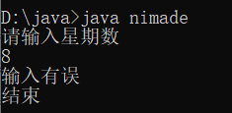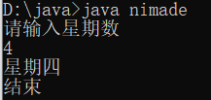

**Case穿透春夏秋冬**

import java.util.Scanner;

public class nimade {

public static void main(String[] args) {

Scanner sc = new Scanner (System.in);

System.out.println("请输入月份");

int week =sc.nextInt();

switch (week){

case 2:

case 3:

case 4:

System.out.println("春季");

break;

case 5:

case 6:

case 7:

System.out.println("夏季");

break;

case 8:

case 9:

case 10:

System.out.println("秋季");

break;

case 11:

case 12:

case 1:

System.out.println("冬季");

break;

default:

System.out.println("输入有误");

break;

}

System.out.println("结束");

}

}

**求0-100偶数和**

public class nimade {

public static void main(String[] args) {

int sum = 0;

for (int i = 1; i <= 100; i++) {

if (i %2 ==0){

sum = sum += i;

}

}

System.out.println(sum);

}

}

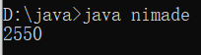

**求0-1000中的水仙花数**

public class nimade {

public static void main(String[] args) {

for (int i = 100; i <= 1000; i++) {

int ge = i % 10;

int bai = i/10%10;

int qian = i/10/10%10;

if (ge*ge*ge+bai*bai*bai+qian*qian*qian == i){

System.out.println(i);

}

}

}

}

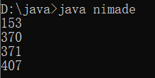

**珠穆朗玛峰**

**一张纸，厚度0.1毫米，折叠多少次能达到珠峰高度**

public class nimade {

public static void main(String[] args) {

int count = 0;

double paper = 0.1;

int zf = 8844430;

while (paper <= zf){

paper *= 2;

count++;

}

System.out.println(count+"次");

}

}

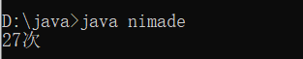

**Do...while循环**

public class nimade {

public static void main(String[] args) {

int j= 0;

do {

System.out.println("我是丁总的爹");

j++;

}

while (j <= 5);

}

}

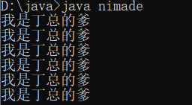

**跳转控制语句**

public class nimade {

public static void main(String[] args) {

for (int j = 1; j <= 5; j++) {

if (j%2 == 0) {

//continue;

//break;

}

System.out.println(j);

}

}

}

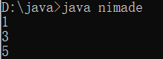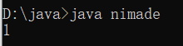

**循环嵌套**

public class nimade {

public static void main(String[] args) {

for (int hour=1;hour<=3; hour++){

for (int minute =1; minute<=4;minute++){

System.out.println(hour+"时"+minute+"分");

}

System.out.println("---------------");

}

}

}

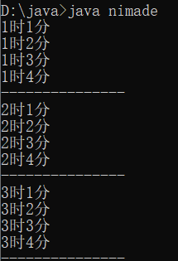

**随机数生成**

import java.util.Random;

public class nimade {

public static void main(String[] args) {

Random r =new Random();

int number = r.nextInt(10);

System.out.println(number);

}

}

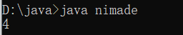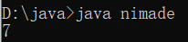

**猜数字**

import java.util.Random;

import java.util.Scanner;

public class nimade {

public static void main(String[] args) {

Random r = new Random();

int number = r.nextInt(100)+1;

while(true){

Scanner sc = new Scanner(System.in);

System.out.println("请输入你要猜的数字");

int guessnumber = sc.nextInt();

if (guessnumber >number){

System.out.println("你猜的数字大了");

}else if (guessnumber <number) {

System.out.println("你猜的数字小了");

}else {

System.out.println("恭喜你猜中了！");

break;

}

}

}

}

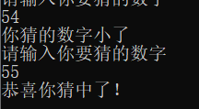

**IDEA中新建步骤**

1. **创建一个空项目**
2. **创建一个新模块**
3. **在模块下的src创建一个包**
4. **在包下新建一个类**
5. **在类中编写代码**
6. **Run**

**数组元素访问**

package xingfa;

import java.util.Random;

import java.util.Scanner;

public class nimade {

public static void main(String[] args) {

int [] arr = new int[3];

System.out.println(arr);

System.out.println(arr[0]);

System.out.println(arr[1]);

System.out.println(arr[2]);

}

}

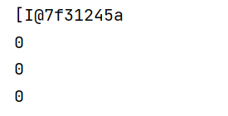

Int类型默认值为0

**遍历**

public class nimade {

public static void main(String[] args) {

int[] arr = {11, 22, 33, 44};

for (int i = 0; i < arr.length; i++) {

System.out.println(arr[i]);

}

}

}

小心指针溢出

使用加强For：直接遍历

for (int j : arr) {

System.out.println(j);

带参数方法练习

public class nimade {

public static void main(String[] args) {

woShiDingZongDeDie(50.5,10.5);

}

public static void woShiDingZongDeDie(double a, double b) {

if (a > b) {

System.out.println("我是丁总的爸爸");

} else {

System.out.println("我是丁总的爷爷");

}

}

}

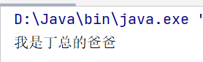

带返回值方法练习

public class nimade {

public static void main(String[] args) {

double result = WND(50.5, 10.5);

System.out.println(result);

System.out.println(WND(50.5, 10.5));

}

public static double WND(double a, double b) {

if (a > b) {

return a;

} else {

return b;

}

}

}

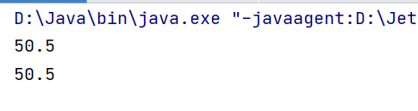

Void 不能加 return

Void类型的方法，直接调用即可

非viod类型的方法，推荐用变量接收调用

方法重载

多个方法在同一个类中；

多个方法具有相同的方法名；

多个方法的参数不同，类型不同或数量不同。

public class nimade {

public static void main(String[] args) {

double result = sum(50.4, 10.11);

System.out.println(result);

int result2 = sum(50, 10);

System.out.println(result2);

int result3 = sum(10, 52, 95);

System.out.println(result3);

}

public static double sum(double a, double b) {

return a + b;

}

public static int sum(int a, int b) {

return a + b;

}

public static int sum(int a, int b, int c) {

return a + b + c;

}

}

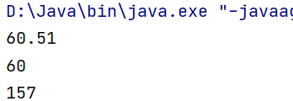

比较两个整数是否相同，兼容全整数类型（byte，short，int，long）强转

public class nimade {

public static void main(String[] args) {

System.out.println(compare(10,20));

System.out.println(compare((byte)10,(byte)20));

System.out.println(compare((short)10,(short)20));

System.out.println(compare(10L,20L));

}

public static boolean compare (int a, int b) {

System.out.println("int");

return a == b;

}

public static boolean compare (byte a, byte b) {

System.out.println("byte");

return a == b;

}

public static boolean compare (short a, short b) {

System.out.println("short");

return a == b;

}

public static boolean compare (long a, long b) {

System.out.println("long");

return a == b;

}

}

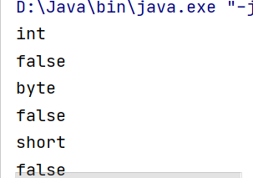

对于基本数据类型的参数，形参的改变，不影响实参的值；

对于引用类型的参数，形参的改变会影响实参的值

public class nimade {

public static void main(String[] args) {

int arr[] = {10, 20, 30};

System.out.println("change前：" + arr[1]);

change(arr);

System.out.println("change后：" + arr[1]);

}

public static void change(int[] arr) {

arr[1] = 200;

}

}

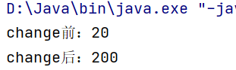

数组遍历

public class nimade {

public static void main(String[] args) {

int[] arr = {10, 20, 30, 40, 50};

printarr(arr);

}

public static void printarr(int[] arr) {

System.out.print("[");

for (int x = 0; x < arr.length; x++) {

if (x == arr.length - 1) {

System.out.print(arr[x]);

} else {

System.out.print(arr[x] + ",");

}

}

System.out.print("]");

}

}

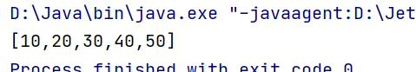

求数组最大值

public class nimade<max> {

public static void main(String[] args) {

int[] arr = {10, 20, 86, 40, 50};

int number = getmax(arr);

System.out.println(number);

}

public static int getmax(int[] arr) {

int max = arr[0];

for (int x = 0; x < arr.length; x++) {

if (max < arr[x]) {

max = arr[x];

}

}

return max;

}

}

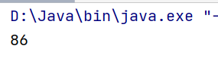

斐波那契数列，求第20个月的兔子数

public class nimade<max> {

public static void main(String[] args) {

int[] arr = new int[20];

arr[0] = 1;

arr[1] = 1;

for (int x = 2; x < arr.length; x++) {

arr[x] = arr[x - 2] + arr[x - 1];

}

System.out.println(arr[19]);

}

}

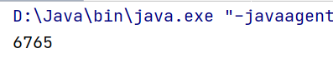

百钱买百鸡案例，公鸡5块一只，母鸡3块一只，小鸡1块三只。求各几只？

public class nimade<max> {

public static void main(String[] args) {

for (int i = 0; i <= 20; i++) {

for (int j = 0; j <= 33; j++) {

int z = 100 - i - j;

if (z % 3 == 0 && i * 5 + j * 3 + z / 3 == 100) {

System.out.println(i + "," + j + "," + z);

}

}

}

}

}

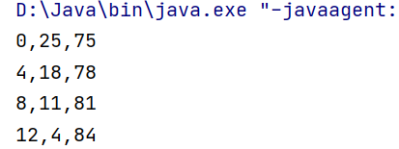

两个数组元素比较

public class nimade<max> {

public static void main(String[] args) {

int[] arr = {11, 22, 33, 44, 55};

int[] arr2 = {11, 22, 33, 44, 55,};

boolean jg = compare(arr, arr2);

System.out.println(jg);

}

public static boolean compare(int[] arr, int[] arr2) {

if (arr.length != arr2.length) {

return false;

}

for (int i = 0; i < arr.length; i++) {

if (arr[i] != arr2[i]) {

return false;

}

}

return true;

}

}

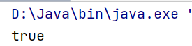

数组元素查找

import java.util.Scanner;

public class nimade<max> {

public static void main(String[] args) {

int[] arr = {11, 22, 33, 44, 55};

Scanner sc = new Scanner(System.in);

System.out.println("请输入需要查找的元素");

int number = sc.nextInt();

int jg = cz(arr, number);

System.out.println(jg);

}

public static int cz(int[] arr, int number) {

int index = -1;

for (int i = 0; i < arr.length; i++) {

if (number == arr[i]) {

index = i;

break;

}

}

return index;

}

}

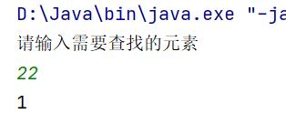

数组元素反转

public class nimade<max> {

public static void main(String[] args) {

int[] arr = {11, 22, 33, 44, 55};

reverse(arr);

printarr(arr);

}

public static void reverse(int[] arr) {

for (int start = 0, end = arr.length - 1; start <= end; start++, end--) {

int temp = arr[start];

arr[start] = arr[end];

arr[end] = temp;

}

}

public static void printarr(int[] arr) {

System.out.print("[");

for (int x = 0; x < arr.length; x++) {

if (x == arr.length - 1) {

System.out.print(arr[x]);

} else {

System.out.print(arr[x] + ",");

}

}

System.out.print("]");

}

}

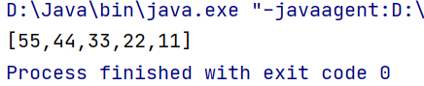

评委打分，去掉最低最高取平均

public class nimade<max> {

public static void main(String[] args) {

int[] arr = new int[6];

Scanner sc = new Scanner(System.in);

for (int i = 0; i < arr.length; i++) {

System.out.println("请输入第" + (i + 1) + "个学生的成绩");

arr[i] = sc.nextInt();

}

int Max = getMax(arr);

int Min = getMin(arr);

int Sum = getSum(arr);

double Avg = ((double) Sum-Max-Min)/ (arr.length-2);

System.out.println(Avg);

}

public static int getMax(int[] arr) {

int max = arr[0];

for (int x = 0; x < arr.length; x++) {

if (max < arr[x]) {

max = arr[x];

}

}

return max;

}

public static int getMin(int[] arr) {

int min = arr[0];

for (int x = 0; x < arr.length; x++) {

if (min > arr[x]) {

min = arr[x];

}

}

return min;

}

public static int getSum(int[] arr) {

int sum = 0;

for (int i = 0; i < arr.length; i++) {

sum += arr[i];

}

return sum;

}

public static void printarr(int[] arr) {

System.out.print("[");

for (int x = 0; x < arr.length; x++) {

if (x == arr.length - 1) {

System.out.print(arr[x]);

} else {

System.out.print(arr[x] + ",");

}

}

System.out.print("]");

}

}

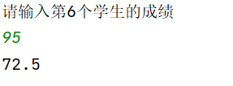

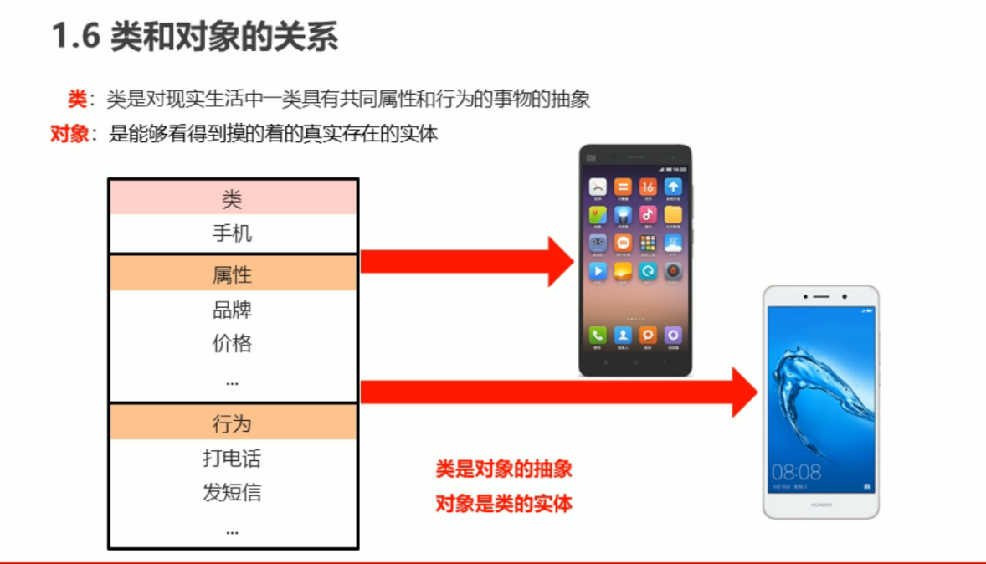

创建一个类，然后创建一个对象，然后创建成员变量、成员方法；赋值成员变量，使用成员方法，输出结果。

public class Phone {

//成员变量

String brand;

int prices;

//成员方法

public void call() {

System.out.println("打电话");

}

public void text() {

System.out.println("发短信");

}

public static void main(String[] args) {

Phone p = new Phone();

p.brand = "iPhone13";

p.prices = 5999;

System.out.println(p.brand);

System.out.println(p.prices);

p.call();

p.text();

}

}

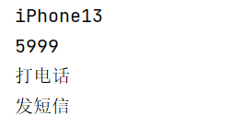

public class Student {

//成员变量

String name;

int age;

//成员方法

public void study() {

System.out.println("学，给我学！");

}

public void homework() {

System.out.println("卷，给我卷！");

}

}

public class StudentTest {

public static void main(String[] args) {

Student s = new Student();

s.name = "陈嘉明";

s.age = 23;

System.out.println(s.name + s.age + "岁");

s.study();

s.homework();

}

}

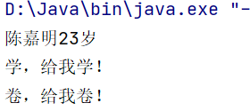

Private

public class Student {

//成员变量

String name;

private int age;

public void setAge(int a) {

if (a<0||a>120){

System.out.println("你输入的年龄有误");

}else{

age = a;

}

}

public int getAge(){

return age;

}

public void show(){

System.out.println(name+","+age+"岁");

}

public class StudentTest {

public static void main(String[] args) {

Student s = new Student();

System.out.println(s);

s.name ="陈嘉明";

s.setAge(23);

s.setAge(-23);

s.show();

}

}

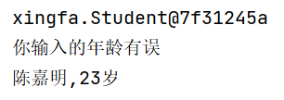

This指代的是成员变量

public class Student {

//成员变量

private String name;

private int age;

public void setName(String name) {

this.name = name;

}

public String getName() {

return name;

}

public void setAge(int a) {

if (a < 0 || a > 120) {

System.out.println("你输入的年龄有误");

} else {

age = a;

}

}

public int getAge() {

return age;

}

public void show() {

System.out.println(name + "," + age + "岁");

}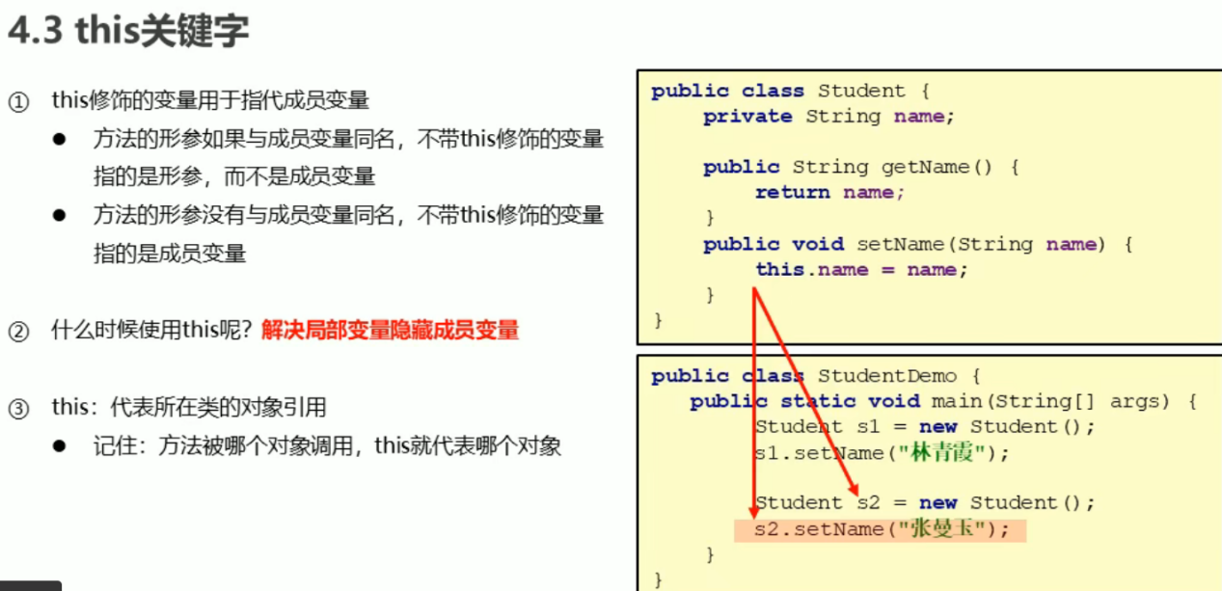

！方法被哪个对象调用，this就代表哪个对象！

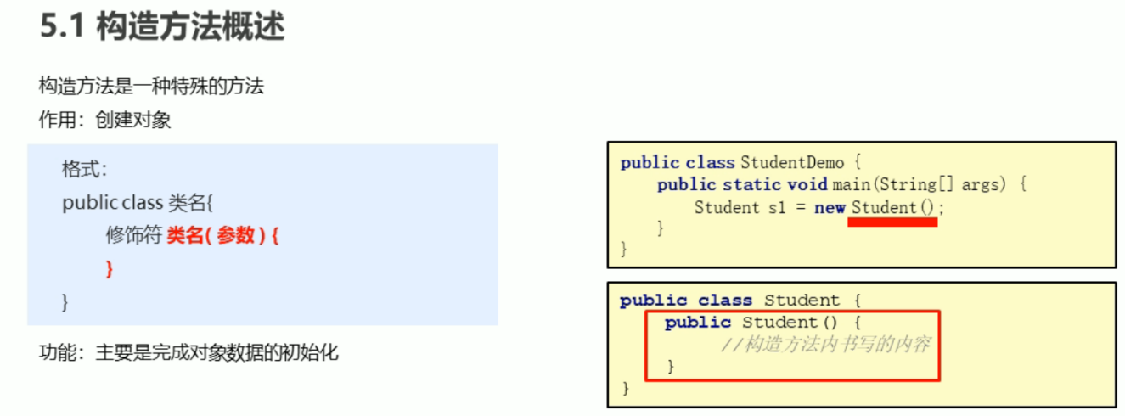

标准类制作：

public class Student {

//成员变量

private String name;

private int age;

// 一个无参数构造方法

public Student() {

}

//带参数的构造方法

public Student(String name, int age) {

this.name = name;

this.age = age;

}

public void setName(String name) {

this.name = name;

}

public String getName() {

return name;

}

public static void main(String[] args) {

//无参构造方法创建对象后使用setXxx()赋值

Student s1 = new Student();

System.out.println(s1);

s1.setName("陈嘉明");

s1.setAge(23);

s1.show();

//使用带参数构造方法直接创建带有属性值的对象

Student s2 = new Student("王祖贤", 26);

s2.show();

}

}

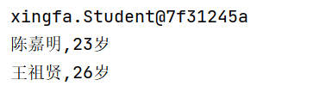

字符串的比较Equals 方法是比较字符串的内容

public class nimade {

public static void main(String[] args) {

//构造方法的方式得到对象

char[] chs = {'a', 'b', 'c'};

String s1 = new String(chs);

String s2 = new String(chs);

//直接赋值的方法得到对象

String s3 = "abc";

String s4 = "abc";

System.out.println(s1 == s2);

System.out.println(s1 == s3);

System.out.println(s3 == s4);

System.out.println("------------");

System.out.println(s1.equals(s2));

System.out.println(s1.equals(s3));

System.out.println(s3.equals(s4));

}

}

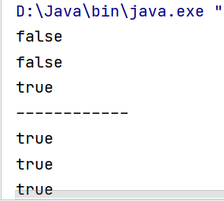

用户登陆

public class nimade {

public static void main(String[] args) {

String username = "丁总爸爸";

String password = "陈嘉明";

Scanner sc = new Scanner(System.in);

for (int i = 0; i < 3; i++) {

System.out.println("请输入用户名");

String name = sc.nextLine();

System.out.println("请输入用户密码");

String key = sc.nextLine();

if (name.equals(username) && key.equals(password)) {

System.out.println("登录成功！");

break;

} else {

if (2-i==0){

System.out.println("您的账户被锁定，请与管理员联系");

}else{

System.out.println("你还有"+(2-i)+"次机会");

}

}

}

}

}

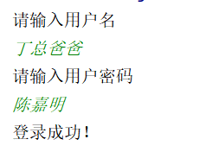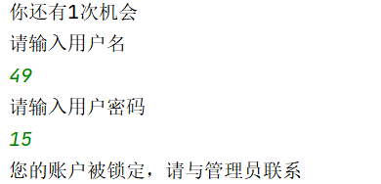

遍历字符串

public class nimade {

public static void main(String[] args) {

Scanner sc = new Scanner(System.in);

System.out.println("请输入一个字符串");

String line = sc.nextLine();

for (int i = 0; i < line.length(); i++) {

System.out.println(line.charAt(i));

}

}

}

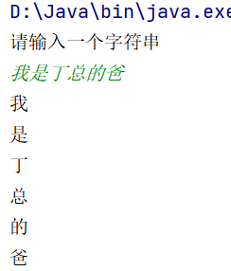

统计字符串次数

public class nimade {

public static void main(String[] args) {

Scanner sc = new Scanner(System.in);

System.out.println("请输入一个字符串");

String line = sc.nextLine();

int bigCount = 0;

int smallCount = 0;

int numberCount = 0;

for (int i = 0; i < line.length(); i++) {

char ch = line.charAt(i);

if (ch >= 'A' && ch <= 'Z') {

bigCount++;

} else if (ch >= 'a' && ch <= 'z'){

smallCount++;

} else if (ch >=0 && ch<=9){

numberCount++;

}

}

System.out.println("大写字母"+bigCount+"小写字母"+smallCount+"数字"+numberCount);

}

}

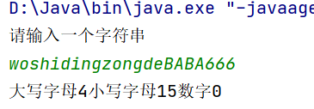

字符串拼接

public class nimade {

public static void main(String[] args) {

int[] arr = {1, 2, 3};

String s = arrayToString(arr);

System.out.println(s);//不需要再printayy方法，直接定义一个String变量接收方法的值就可以输出了。

}

public static String arrayToString(int[] arr) {

String s = "";

s += "[";

for (int i = 0; i < arr.length; i++) {

if (i == arr.length - 1) {

s += arr[i];

} else {

s += arr[i];

s += ", ";

}

}

s += "]";

return s;

}

}

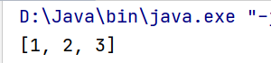

字符串反转

public class nimade {

public static void main(String[] args) {

Scanner sc = new Scanner(System.in);

System.out.println("请输入一个字符串");

String line = sc.nextLine();

String jg = reverse(line);

System.out.println(jg);

}

public static String reverse(String s) {

String ss = "";

for (int i = s.length() - 1; i >= 0; i--) {

ss += s.charAt(i);

}

return ss;

}

}

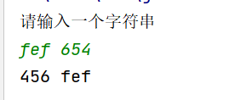

StringBuilder 构造方法创建可变字符串对象

public class nimade {

public static void main(String[] args) {

StringBuilder a = new StringBuilder("我恁爹！");

System.out.println(a);

System.out.println(a.length());

}

}

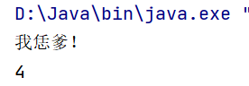

Append链式编程，Reverse方法

public class nimade {  
 public static void main(String[] args) {  
 StringBuilder a = new StringBuilder("我");  
 a.append("是").append("丁总的").append("爹!");  
 System.out.println(a);  
 a.reverse();  
 System.out.println(a);  
 }  
}

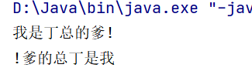

String 和StringBuilder互相转换

public class nimade {

public static void main(String[] args) {

//String 转换成StringBuilder;

String s = "林总早上好！";

StringBuilder a = new StringBuilder(s);

System.out.println(a);

//StringBuilder转换成String;

StringBuilder b = new StringBuilder();

b.append("丁总早上好！");

String c = b.toString();

System.out.println(c);

}

}

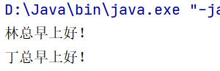

利用String Builder实现字符串的反转

public class nimade {

public static void main(String[] args) {

Scanner sc = new Scanner(System.in);

System.out.println("请输入一个字符串：");

String line = sc.nextLine();

String jg = reverse(line);

System.out.println(jg);

}

public static String reverse(String s) {

StringBuilder sb = new StringBuilder(s);

sb.reverse();

String result = sb.toString();

return result;

}

}

红字的四行代码可以用一行简化：

return new StringBuilder(s).reverse().toString();

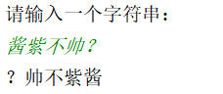

Arraylist的构造和添加

public class nimade {

public static void main(String[] args) {

ArrayList<String> array = new ArrayList<String>();

array.add("丁总");

array.add("林总");

array.add("小陈");

array.add("贵物一个");

array.add(2, "666");

System.out.println(array);

}

}

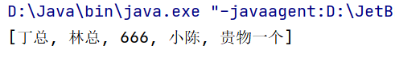

ArrayList遍历字符串

public class nimade {

public static void main(String[] args) {

ArrayList<String> array = new ArrayList<String>();

array.add("丁总");

array.add("林总");

array.add("小陈");

array.add("贵物一个");

array.add(2, "666");

System.out.println(array);

for (int i = 0; i < array.size(); i++) {

String s = array.get(i);

System.out.println(s);

}

}

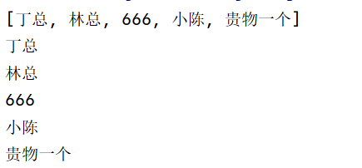

ArrayList<Student> array= new ArrayList<Student>();

Student s1 = new Student("王祖贤", 26);

Student s2 = new Student("陈嘉明", 23);

Student s3 = new Student("钟楚红", 25);

array.add(s1);

array.add(s2);

array.add(s3);

for (int i = 0; i < array.size(); i++) {

Student s = array.get(i);

System.out.println(s.getName()+s.getAge());

}

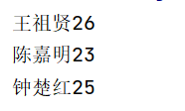

ArrayList存储学生对象并遍历

public class StudentTest {

public static void main(String[] args) {

ArrayList<Student> array = new ArrayList<Student>();

addStudent(array);

addStudent(array);

addStudent(array);

for (int i = 0; i < array.size(); i++) {

Student s = array.get(i);

System.out.println(s.getName() + s.getAge());

}

}

public static void addStudent(ArrayList<Student> array) {

Scanner sc = new Scanner(System.in);

System.out.println("请输入学生姓名");

String name = sc.nextLine();

System.out.println("请输入学生年龄");

String age = sc.nextLine();

Student s = new Student();

s.setName(name);

s.setAge(age);

array.add(s); 忘记，往集合中添加学生对象

}

}

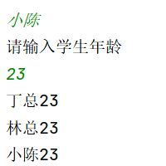

魔法！学生类，alt+insert可以自动生成构造方法

学生管理系统之主界面

public class StudentManager {

public static void main(String[] args) {

while (true) {

System.out.println("--------欢迎来到学生管理系统---------");

System.out.println("1 添加学生");

System.out.println("2 删除学生");

System.out.println("3 修改学生");

System.out.println("4 查看所有学生");

System.out.println("5 退出");

System.out.println("请输入你的选择");

Scanner sc = new Scanner(System.in);

String line = sc.nextLine();

switch (line) {

case "1":

System.out.println("添加学生");

break;

case "2":

System.out.println("删除学生");

break;

case "3":

System.out.println("修改学生");

break;

case "4":

System.out.println("查看所有学生");

break;

case "5":

System.out.println("谢谢使用！");

System.exit(0);

}

}

}

}

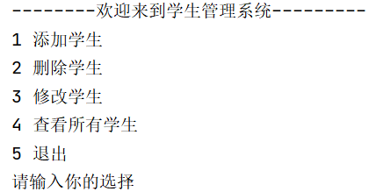

学生管理系统之添加学生

public static void addStudent(ArrayList<Student> array) {

Scanner sc = new Scanner(System.in);

System.out.println("请输入学生学号");

String sid = sc.nextLine();

System.out.println("请输入学生姓名");

String name = sc.nextLine();

System.out.println("请输入学生年龄");

String age = sc.nextLine();

System.out.println("请输入学生居住地");

String address = sc.nextLine();

Student s = new Student();

s.setSid(sid);

s.setName(name);

s.setAge(age);

s.setAddress(address);

array.add(s);

System.out.println("添加学生成功");

}

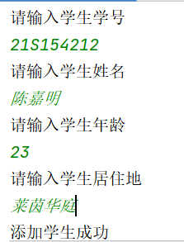

学生管理系统之查看所有学生

public static void findAllStudent(ArrayList<Student> array) {

if (array.size() == 0) {

System.out.println("无学生信息，请先添加后查看！");

return;

}

System.out.println("学号\t\t\t姓名\t\t年龄\t\t居住地");

for (int i = 0; i < array.size(); i++) {

array.get(i);

Student s = array.get(i);

System.out.println(s.getSid() + "\t" + s.getName() + "\t" + s.getAge() + "\t" + s.getAddress() + "\t");

}

}

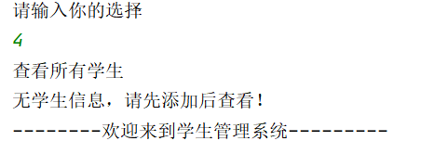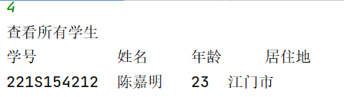

学生管理系统之删除学生

public static void delectStudent(ArrayList<Student> array) {

Scanner sc = new Scanner(System.in);

System.out.println("请输入你要删除的学生学号");

String sid = sc.nextLine();

int index = -1;

for (int i = 0; i < array.size();i++){

Student s =array.get(i);

if (s.getSid().equals(sid)){

index = i;

break;

}

}

if (index == -1){

System.out.println("该学号不存在，请重新输入！");

} else {

array.remove(index);

System.out.println("删除学生信息成功！");

}

}

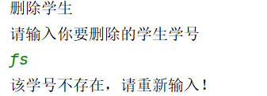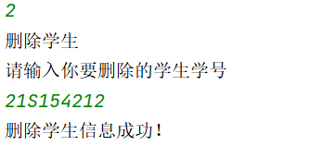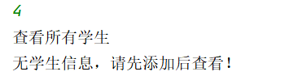

学生管理系统之修改学生

public static void updateStudent(ArrayList<Student> array) {

Scanner sc = new Scanner(System.in);

System.out.println("请输入要修改的学生学号：");

String sid = sc.nextLine();

System.out.println("请输入学生新姓名：");

String name = sc.nextLine();

System.out.println("请输入学生新年龄：");

String age = sc.nextLine();

System.out.println("请输入学生新居住地：");

String address = sc.nextLine();

Student s = new Student();

s.setSid(sid);

s.setName(name);

s.setAge(age);

s.setAddress(address);

for (int i = 0; i < array.size(); i++) {

Student student = array.get(i);

if (student.getSid().equals(sid)) {

array.set(i, s);

break;

}

}

System.out.println("修改成功！");

}

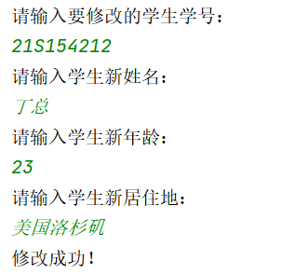

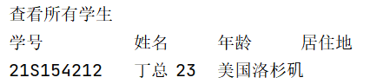

学生管理系统之学号重复问题

public static boolean isused(ArrayList<Student> array,String sid){

boolean flag = false;

for ( int i =0; i< array.size();i++){

Student s =array.get(i);

if (s.getSid().equals(sid)){

flag = true;

break;

}

}

return flag;

}

Scanner sc = new Scanner(System.in);

String sid;

while (true) {

System.out.println("请输入学生学号");

sid = sc.nextLine();

boolean flag = isused(array, sid);

if (flag) {

System.out.println("你输入的学号已经被使用，请重新输入");

} else {

break;

}

}

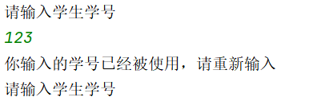

继承：子承父类

public class Zi extends Fu{

public void method() {

System.out.println("method方法被调用");

}

}

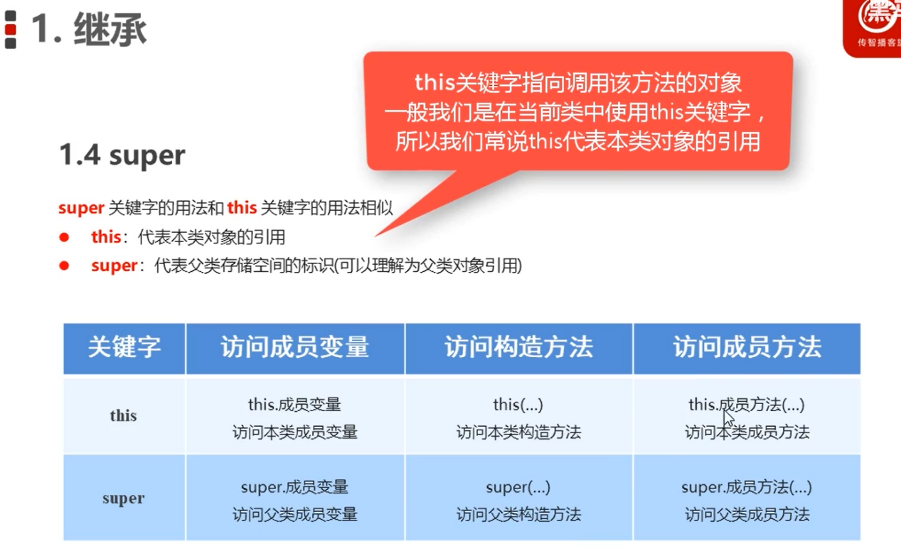

public class Zi extends Fu{

public int age =20;

public void method() {

int age =30;

System.out.println(age);

System.out.println(this.age);

System.out.println(super.age);

}

}

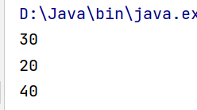

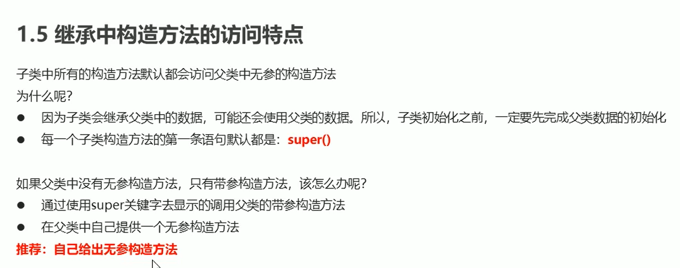

public class Fu {

public Fu() {

System.out.println("Fu中无参方法被调用");

}

public Fu(int age) {

System.out.println("Fu中带参方法被调用");

}

}

public class Zi extends Fu {

public Zi() {

super(20);

System.out.println("Zi中无参构造方法被调用");

}

public Zi(int age) {

super(30);

System.out.println("Zi中带参构造方法被调用");

}

}

public class Demo {

public static void main(String[] args) {

Zi z = new Zi();

Zi z2 = new Zi(20);

}

}

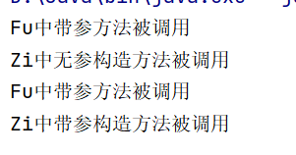

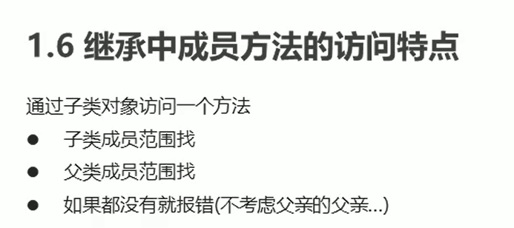

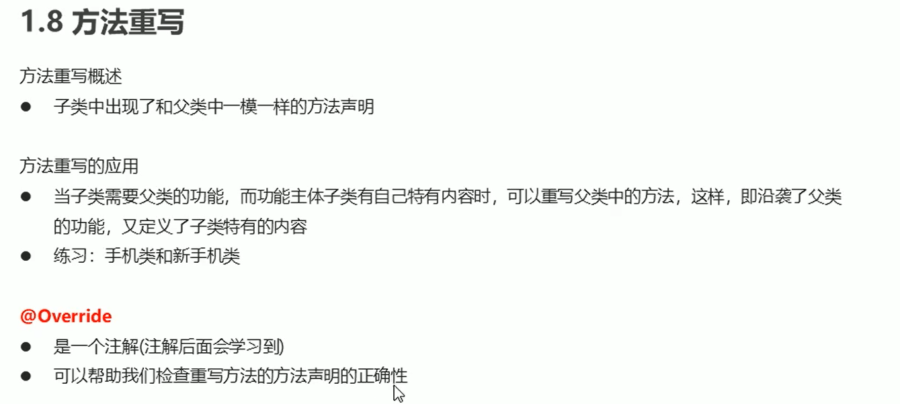

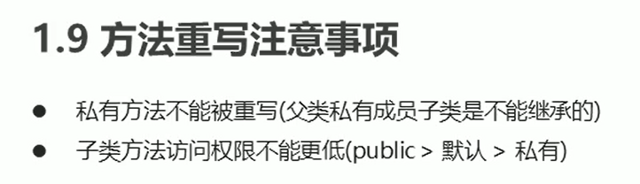

老师与学生

！构造一个带参方法，系统的默认无参构造方法就没了，需要手动再写一个。

package 老师与学生;

public class Person {

private String name;

private int age;

public Person() {

}

public Person(String name, int age) {

this.name = name;

this.age = age;

}

public String getName() {

return name;

}

public int getAge() {

return age;

}

public void setName(String name) {

this.name = name;

}

public void setAge(int age) {

this.age = age;

}

}

public class Demo {

public static void main(String[] args) {

//创建老师类对象并测试

Teacher t1 = new Teacher();

t1.setName("王祖贤");

t1.setAge(36);

System.out.println(t1.getName() + t1.getAge() + "岁");

t1.teach();

Teacher t2 = new Teacher("陈嘉明", 23);

System.out.println(t2.getName() + t2.getAge() + "岁");

t2.teach();

//创建学生类对象并测试

Student s1 = new Student();

s1.setName("小王");

s1.setAge(16);

System.out.println(s1.getName() + s1.getAge() + "岁");

s1.study();

Student s2 = new Student("小李", 13);

System.out.println(s2.getName() + s2.getAge() + "岁");

s2.study();

}

}

public class Teacher extends Person {

public Teacher() {

//无参构造方法

}

public Teacher(String name, int age) {

super(name, age);

}

public void teach() {

System.out.println("Ta是老师");

}

}

public class Student extends Person {

public Student() {

//无参构造方法

}

public Student(String name, int age) {

super(name, age);

}

public void study() {

System.out.println("Ta是学生");

}

}

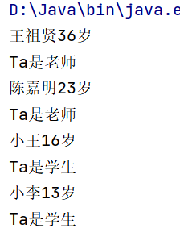

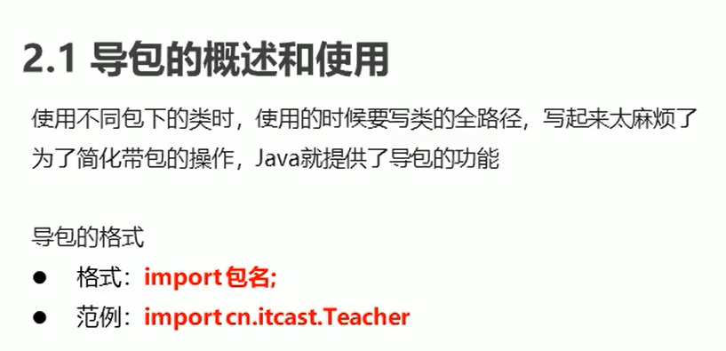

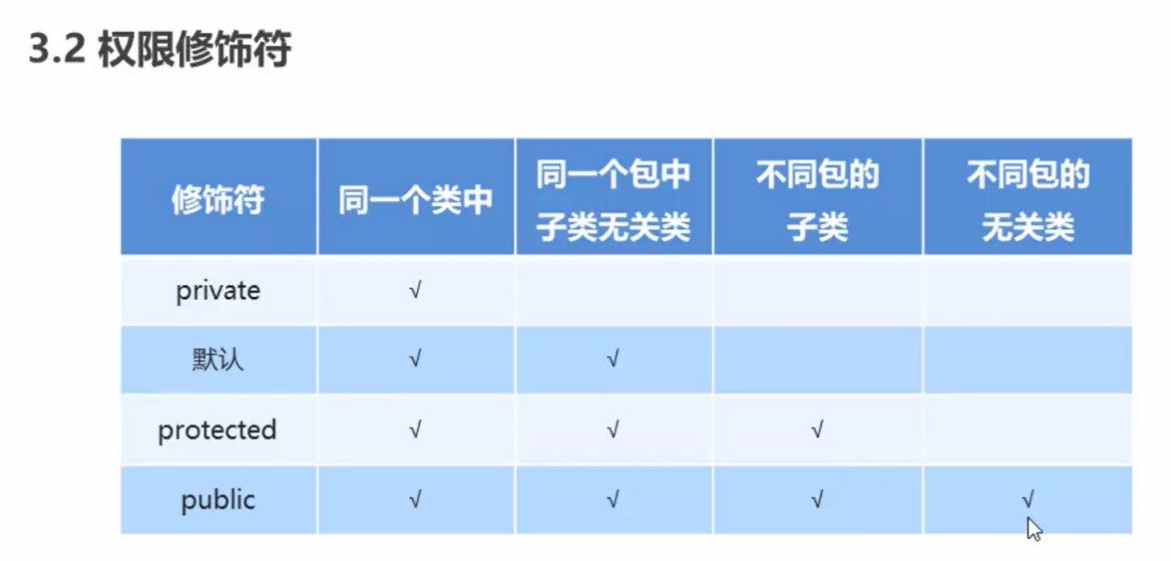

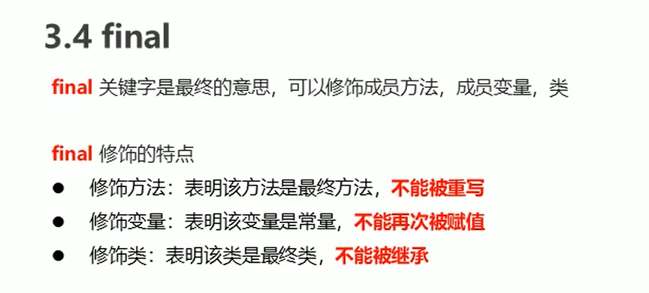

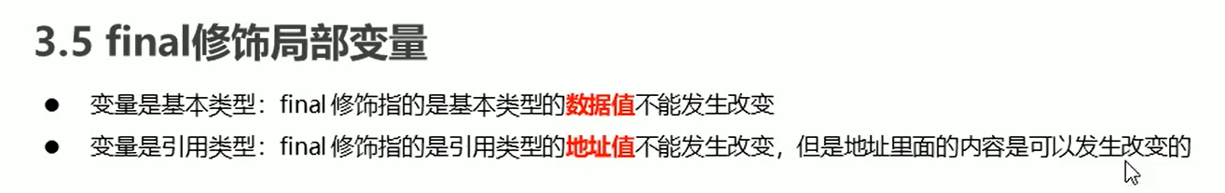

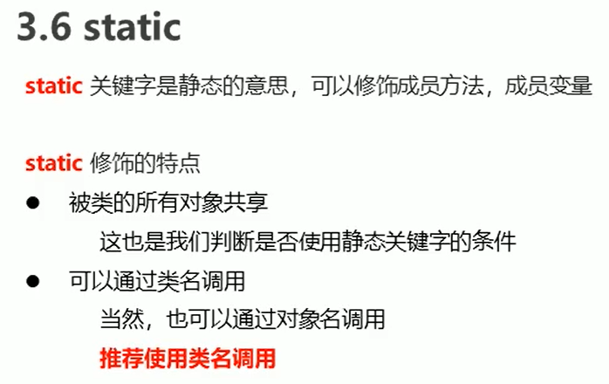

public class Student {

public String name;

public int age;

public static String university;

public void show(){

System.out.println(name+age+"岁"+university);

}

}

public class demo {  
 public static void main(String[] args) {  
 Student.university = "哈尔滨工业大学";  
 Student s1 = new Student();  
 s1.name = "陈嘉明";  
 s1.age = 23;  
 Student s2 = new Student();  
 s2.name = "张三";  
 s2.age = 22;  
 s1.show();  
 s2.show();  
 }  
}

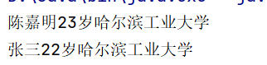

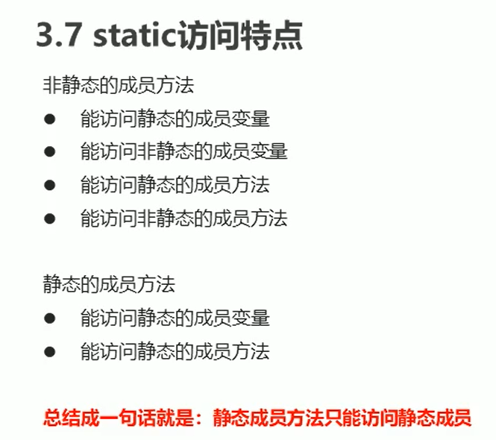

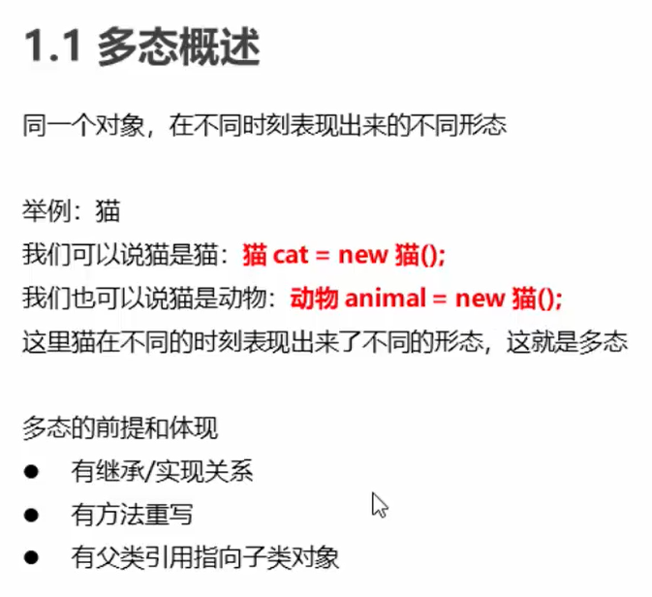

package 猫多态;  
  
public class Animal {  
 public void eat() {  
 System.out.println("猫吃老鼠");  
 }  
}

public class Cat extends Animal {  
 @Override  
 public void eat() {  
 System.out.println("猫吃鱼");//直接eat就可以重写  
 }  
}

public class Demo {

public static void main(String[] args) {

Animal a = new Cat();

a.eat();

}

}

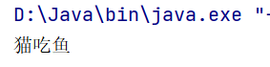

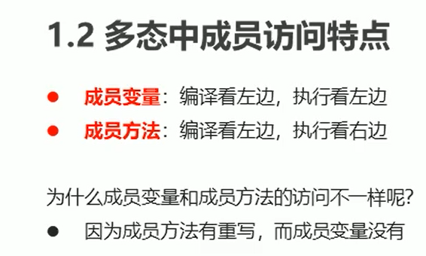

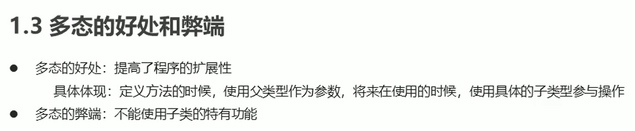

public class AnimalOperator {  
 public void useAnimal(Animal a){  
 a.eat();  
 }  
}

public class Demo {  
 public static void main(String[] args) {  
 AnimalOperator a0 = new AnimalOperator();  
 Animal a = new Cat();  
 a.eat();  
 Animal d = new Dog();  
 d.eat();  
 }  
}

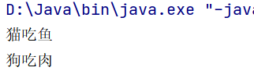

多态中的向下转型

public class Demo {  
 public static void main(String[] args) {  
 AnimalOperator a0 = new AnimalOperator();  
 Animal a = new Cat();  
 a.eat();  
 Cat c = (Cat)a;  
 ((Cat) a).play();  
 c.play();  
 }  
}

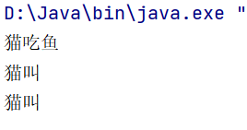

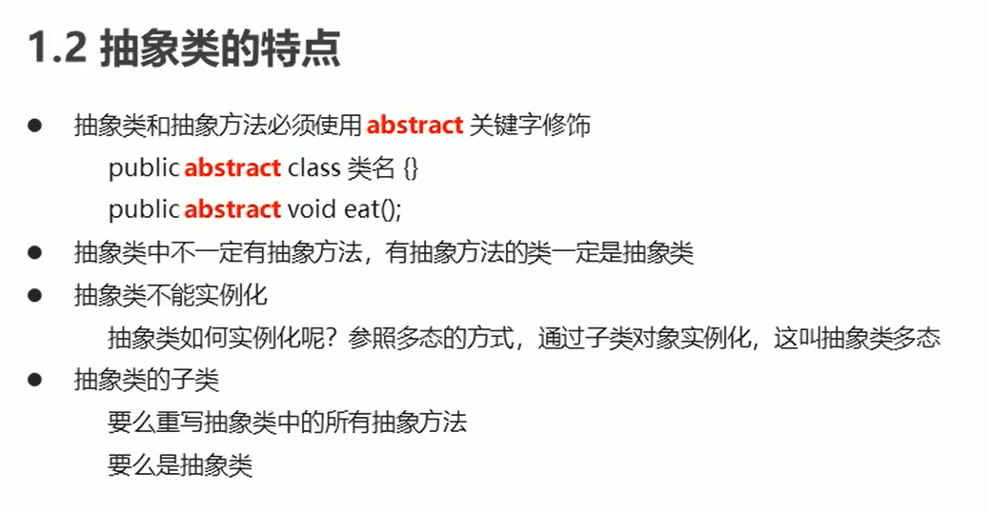

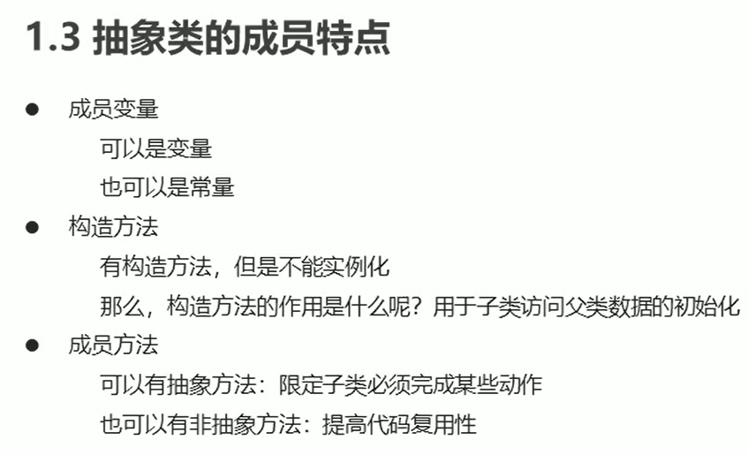

package 猫狗抽象类;  
public abstract class Animal {  
 public String name;  
 public int age;  
  
 public Animal() {  
 }  
  
 public Animal(String name, int age) {  
 this.name = name;  
 this.age = age;  
 }  
  
 public String getName() {  
 return name;  
 }  
  
 public void setName(String name) {  
 this.name = name;  
 }  
  
 public int getAge() {  
 return age;  
 }  
  
 public void setAge(int age) {  
 this.age = age;  
 }  
  
 public abstract void eat();  
}

package 猫狗抽象类;  
  
public class Cat extends Animal{  
 public Cat() {  
 }  
  
 public Cat(String name, int age) {  
 super(name, age);  
 }  
  
 @Override  
 public void eat() {  
 System.out.println("猫吃鱼");  
 }  
}

package 猫狗抽象类;  
  
public class Dog extends Animal {  
 public Dog() {  
 }  
  
 public Dog(String name, int age) {  
 super(name, age);  
 }  
  
 @Override  
 public void eat() {  
 System.out.println("狗吃肉");  
 }  
}

package 猫狗抽象类;

public class Demo {

public static void main(String[] args) {

Animal a = new Cat();

a.setName("pussy");

a.setAge(5);

a.eat();

System.out.println("------------");

Animal d = new Dog("丁总", 5);

System.out.println(d.getName() + "," + d.getAge() + "岁");

d.eat();

}

}

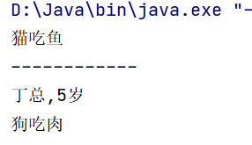

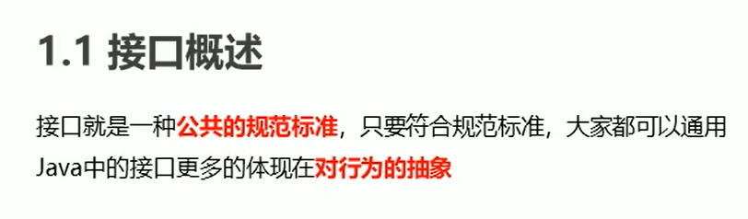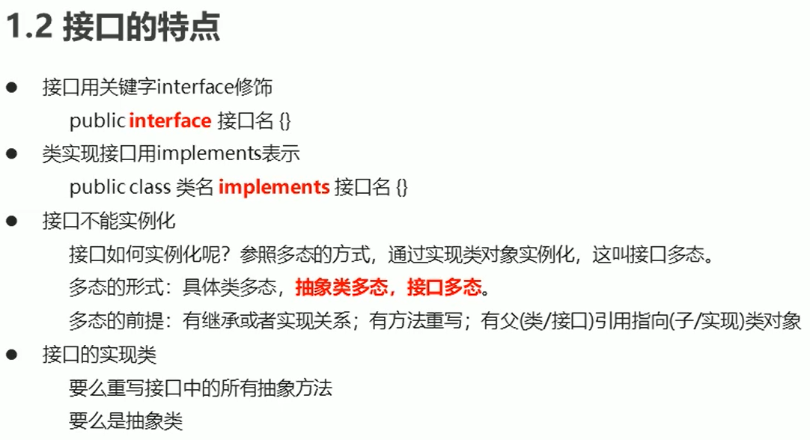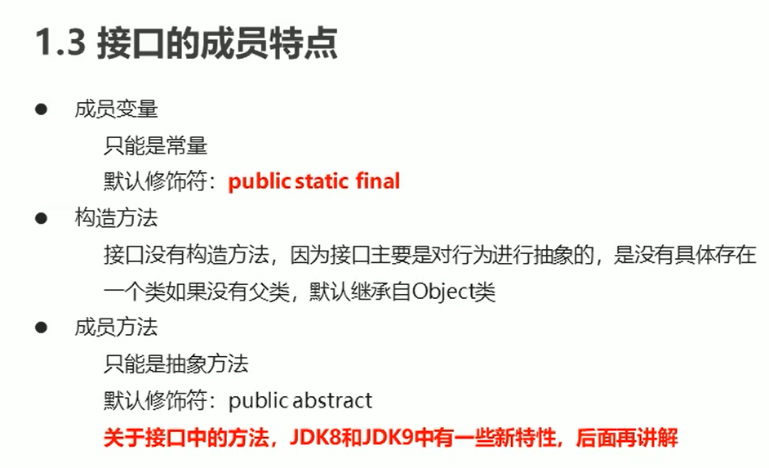

package 猫狗接口;  
  
public interface Jump {  
 public abstract void jump();  
}

public class Demo {  
 public static void main(String[] args) {  
 Cat c = new Cat("加菲", 5);  
 System.out.println(c.name + c.age);  
 c.eat();  
 c.jump();  
 Dog d = new Dog("丁总", 23);  
 System.out.println(d.name + d.age);  
 d.eat();  
 d.jump();  
  
 }  
}

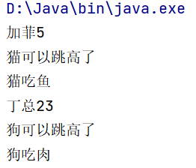

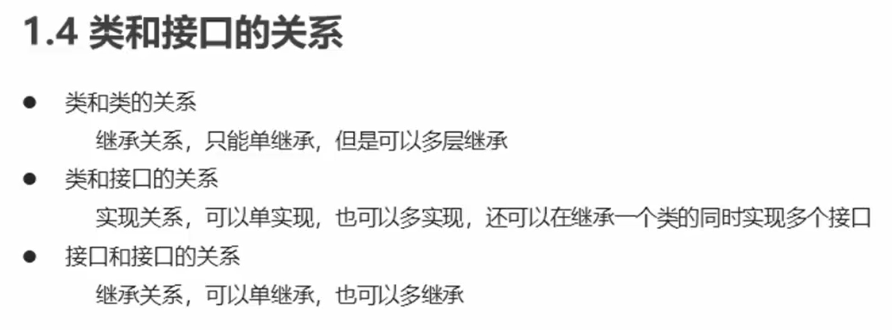

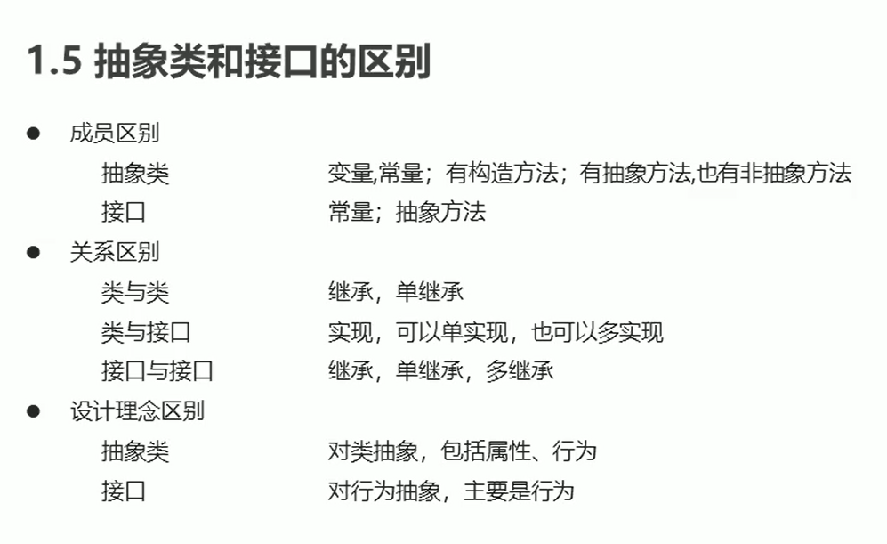

抽象类是对事物的抽象，而接口是对行为的抽象

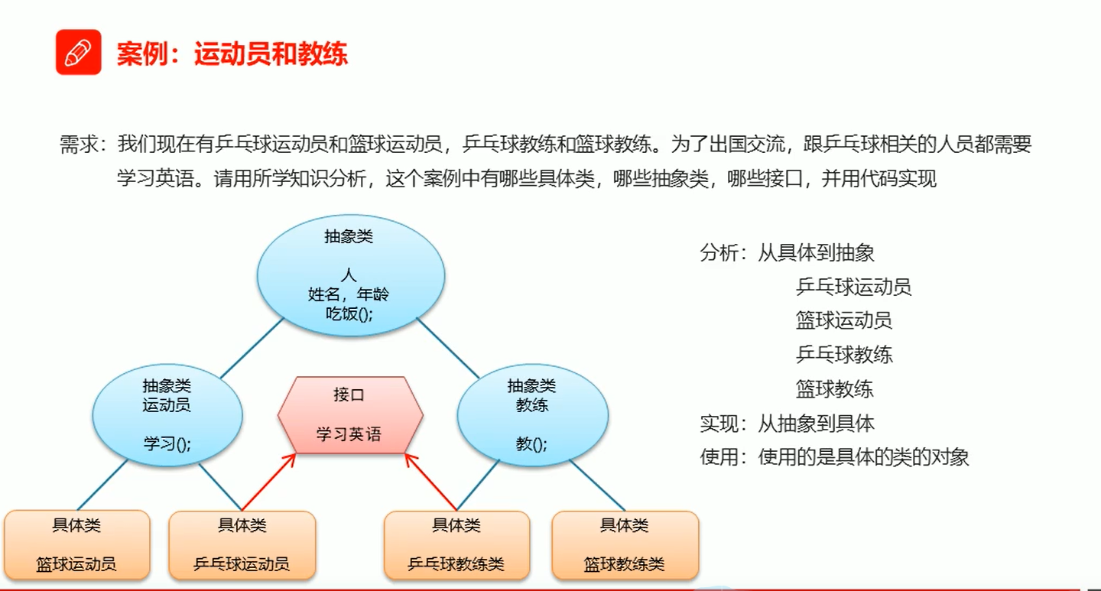

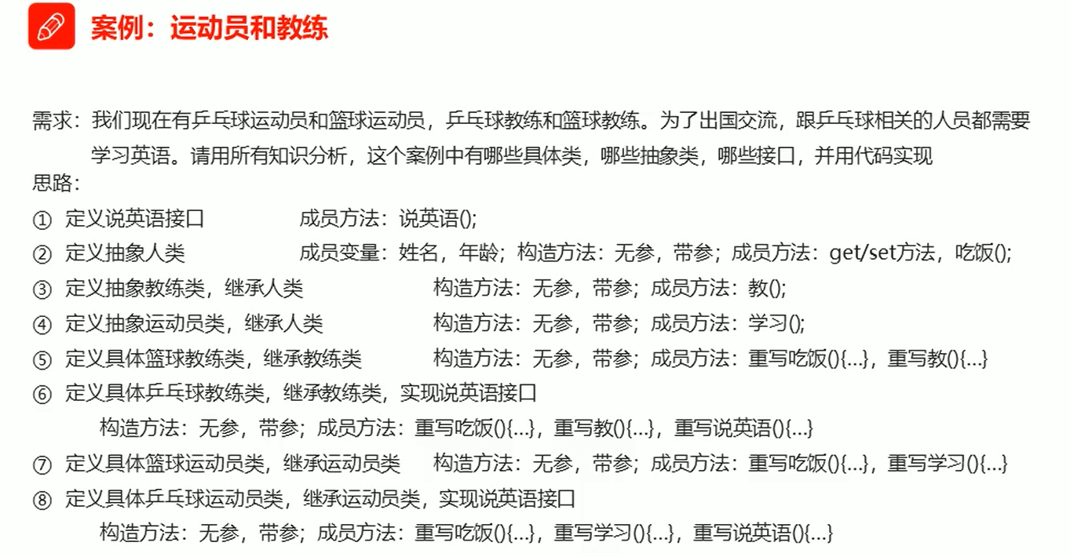

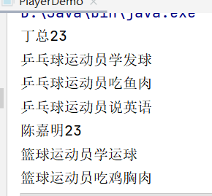

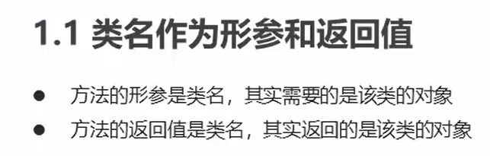

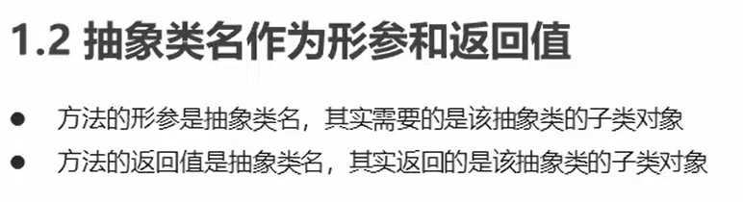

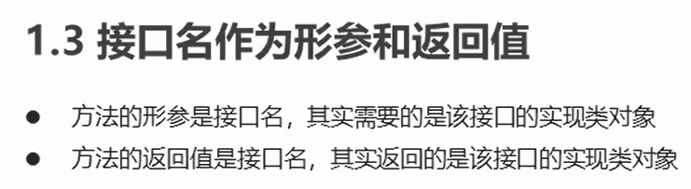

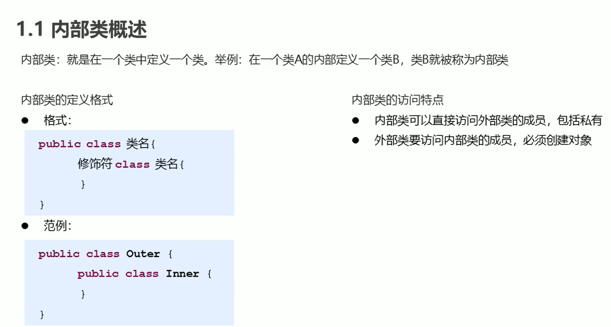

package 内部类;  
public class Outer {  
 private int num = 20;  
 public class inner {  
 public void show() {  
 System.out.println("这里是内部类" + num);  
 }  
 }  
 }

public class Demo {  
 public static void main(String[] args) {  
 Outer.inner a = new Outer().new inner();  
 a.show();  
 }  
}

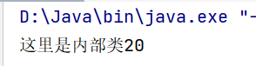

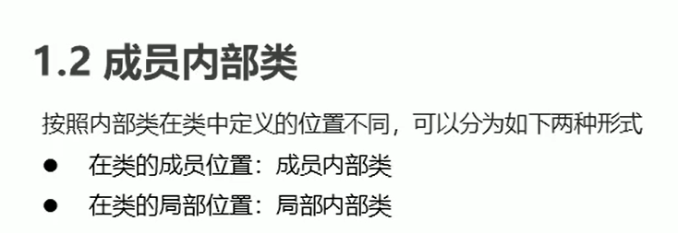

public class Outer {

private int num = 20;

private class inner {

public void show() {

System.out.println("这里是内部类" + num);

}

}

public void method() {

inner i = new inner();

i.show();

}

}

public class Demo {

public static void main(String[] args) {

Outer a = new Outer();

a.method();

}

}

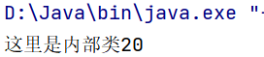

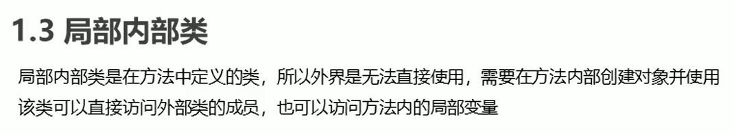

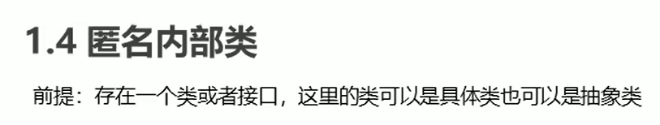

本质是一个继承了该类或者实现了该接口的子类匿名对象

public interface Inter {  
 void show();  
}

public class Outer {  
 public void method() {  
 new Inter() {  
 @Override  
 public void show() {  
 System.out.println("匿名内部类");  
 }  
 }.show();  
 }  
}

public class Demo {  
 public static void main(String[] args) {  
 Outer a = new Outer();  
 a.method();  
 }  
}

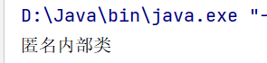

如果需要多次调用，这个对象应该有一个返回值类型，整体可以看成Inter接口的实现类对象，那就可以按照多态的形式赋值给Inter这个接口。如果Inter是个类，那匿名内部类就是该类的子类对象。

public class Outer {  
 public void method() {  
 Inter i = new Inter() {  
 @Override  
 public void show() {  
 System.out.println("我是匿名内部类");  
 }  
 };  
 i.show();  
 i.show();  
 i.show();  
 }  
}

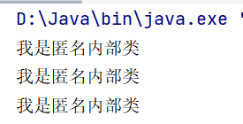

接口操作类，里面有一个方法，方法的参数名是接口名，要的是该接口的实现类对象，所以需要新建一个实现类implement这个接口，然后重写接口方法。就可以创建接口操作类的对象，调用接口操作类里的方法了。

但如果需要调用的次数过多很麻烦，那么可以直接按照匿名内部类的格式，因为匿名内部类的格式本质就是一个对象，并且是实现了该接口的对象。

package 匿名内部类;  
public interface Jump {  
 void jump();  
}

public class JumppingOperator {  
 public void method(Jump j) {  
 j.jump();  
 }  
}

public class Cat implements Jump {  
 @Override  
 public void jump() {  
 System.out.println("猫可以跳高了");  
 }  
}

public class Demo {  
 public static void main(String[] args) {  
 JumppingOperator j0 = new JumppingOperator();  
 Jump j = new Cat();  
 j0.method(j);  
 System.out.println("-----------");  
 j0.method(new Jump() {  
 @Override  
 public void jump() {  
 System.out.println("猫可以跳高了");  
 }  
 });  
 j0.method(new Jump() {  
 @Override  
 public void jump() {  
 System.out.println("狗可以跳高了");  
 }  
 });  
 }  
}

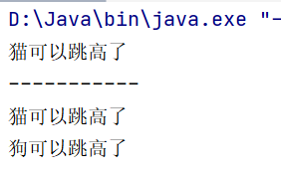

返回当前时间long，毫秒

public class Demo {  
 public static void main(String[] args) {  
 long start = System.currentTimeMillis();  
 for (int i = 0; i < 1000; i++) {  
 System.out.println(i);  
 }  
 long end = System.currentTimeMillis();  
 System.out.println("总耗时"+(end-start)+"毫秒");  
 }  
}

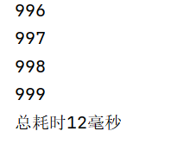

重写Object中的To String方法

@Override  
public String toString() {  
 return "Person{" +  
 "name='" + name + '\'' +  
 ", age=" + age +  
 '}';  
}

//创建老师类对象并测试  
Teacher t = new Teacher("陈嘉明", 23);  
System.out.println(t.toString());  
t.teach();  
//创建学生类对象并测试  
Student s = new Student("小李", 13);  
System.out.println(s.toString());  
s.study();

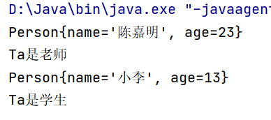

Ctrl+B查看方法源码

重写Object中的equals方法

Student s1 = new Student("小李", 13);

System.out.println(s1.toString());

Student s2 = new Student("小李", 13);

System.out.println(s2.toString());

System.out.println(s1.equals(s2));

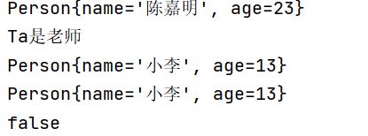

@Override  
public boolean equals(Object o) {  
 //this -- s1 ; o -- s2（向上转型，把s2给了0）  
 //比较地址是否相同，相同直接返回true  
 if (this == o) return true;  
  
 //判断参数是否为null，判断两个对象是否来自同一个类  
 if (o == null || getClass() != o.getClass()) return false;  
  
 //强制转型，向下转型,把o转为Person类型，Person= s2；  
 Person person = (Person) o;  
  
 //比较年龄内容是否相同  
 if (age != person.age) return false;  
   
 //比较姓名内容是否相同  
 return name != null ? name.equals(person.name) : person.name == null;  
}

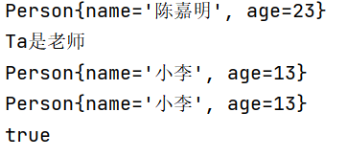

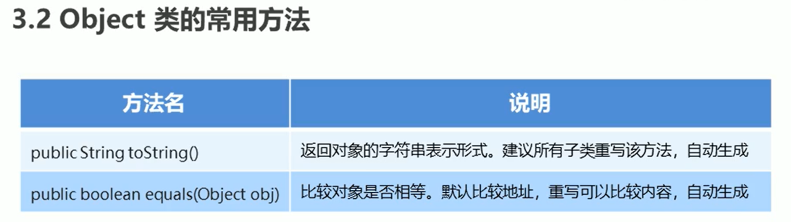

冒泡排序

public class Demo {

public static void main(String[] args) {

int[] arr = {14, 28, 85, 44, 7};

System.out.println(arrayToString(arr));

for (int x = 0; x < arr.length - 1; x++) {

for (int i = 0; i < arr.length - 1; i++) {

if (arr[i] > arr[i + 1]) {

int temp = arr[i + 1];

arr[i + 1] = arr[i];

arr[i] = temp;

}

}

}

System.out.println(arrayToString(arr));

}

public static String arrayToString(int[] arr) {

StringBuilder sb = new StringBuilder();

sb.append("[");

for (int i = 0; i < arr.length; i++) {

if (i == arr.length - 1) {

sb.append(arr[i]);

} else {

sb.append(arr[i]).append(", ");

}

}

sb.append("]");

String s = sb.toString();

return s;

}

}

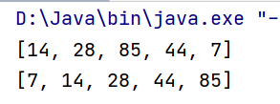

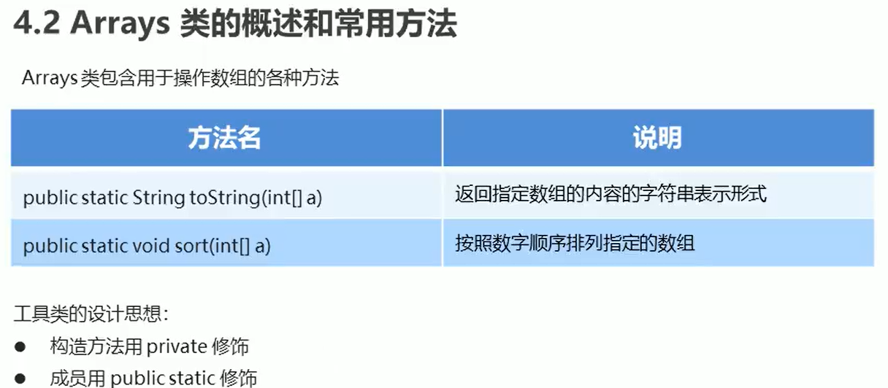

public class ArrayDemo {

public static void main(String[] args) {

int[] arr = {14, 28, 85, 44, 7};

System.out.println("排序前"+ Arrays.toString(arr));

Arrays.sort(arr);

System.out.println("排序后"+ Arrays.toString(arr));

}

}

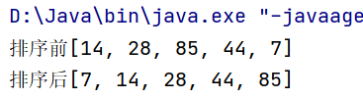

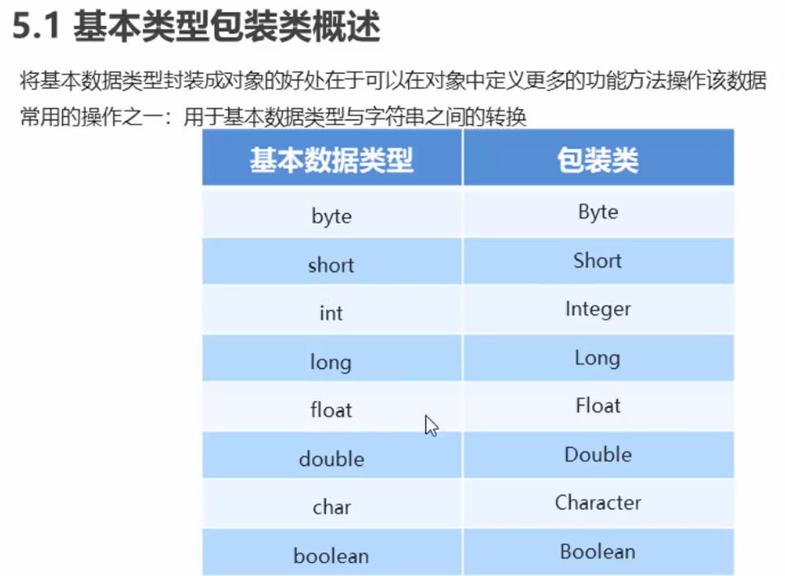

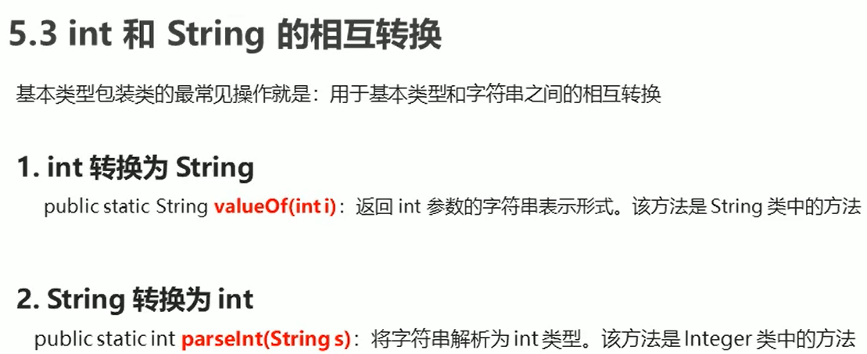

public class ArrayDemo {  
 public static void main(String[] args) {  
 int number = 100;  
 String s1 = String.valueOf(number);  
 System.out.println(s1);  
 System.out.println("----------------");  
 String s = "100";  
 Integer i = Integer.valueOf(s);  
 int x = i.intValue();  
 System.out.println(x);  
 System.out.println("----------------");  
 int y = Integer.parseInt(s);  
 System.out.println(y);  
 }  
}

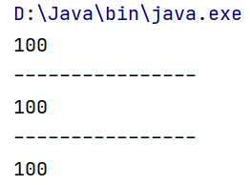

字符串中的数据排序

public class Demo {  
 public static void main(String[] args) {  
 String s = "15,59,75,32,69,12";  
 String[] StringArray = s.split(",");  
 int[] arr = new int[StringArray.length];  
 for (int i = 0; i < arr.length; i++) {  
 arr[i] = Integer.parseInt(StringArray[i]);  
 }  
 Arrays.sort(arr);  
 StringBuilder sb = new StringBuilder();  
 for (int i = 0; i < arr.length; i++) {  
 if (i == args.length - 1) {  
 sb.append(arr[i]);  
 } else {  
 sb.append(arr[i]).append(" ");  
 }  
 }  
 String result = sb.toString();  
 System.out.println(result);  
 }  
}

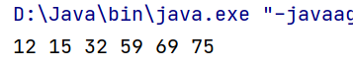

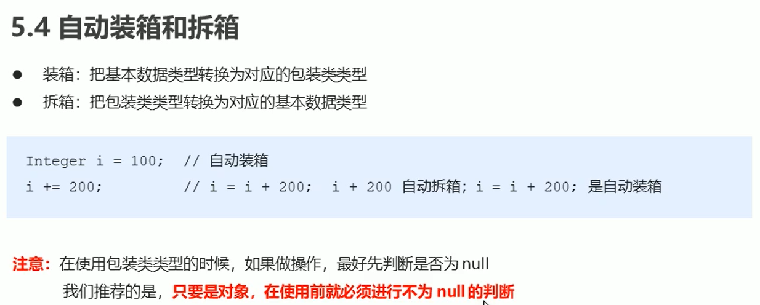

public class Demo {  
 public static void main(String[] args) {  
 Integer i = Integer.valueOf(100);  
 Integer ii = 100;  
 ii += 200;  
 System.out.println(ii);  
 Integer iii = 200;  
 if (iii != null) {  
 iii += 200;  
 }  
 System.out.println(iii);  
 }  
}

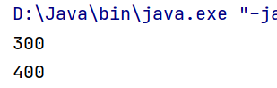S

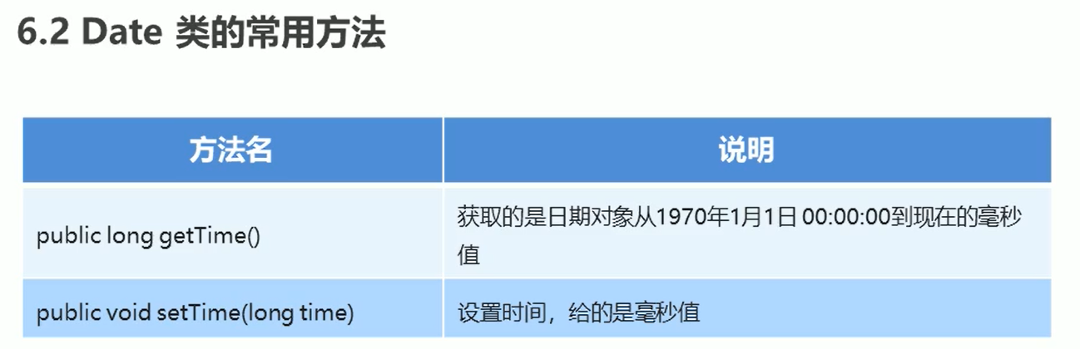import java.util.Date;

public class DateDemo {

public static void main(String[] args) {

Date d1 = new Date();

System.out.println(d1);

long date =1000*60*60;

Date d2 = new Date(date);

System.out.println(d2);

Date d3 = new Date(date);

long time = System.currentTimeMillis();

d3.setTime(time);

System.out.println(d3);

}

}

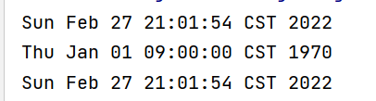

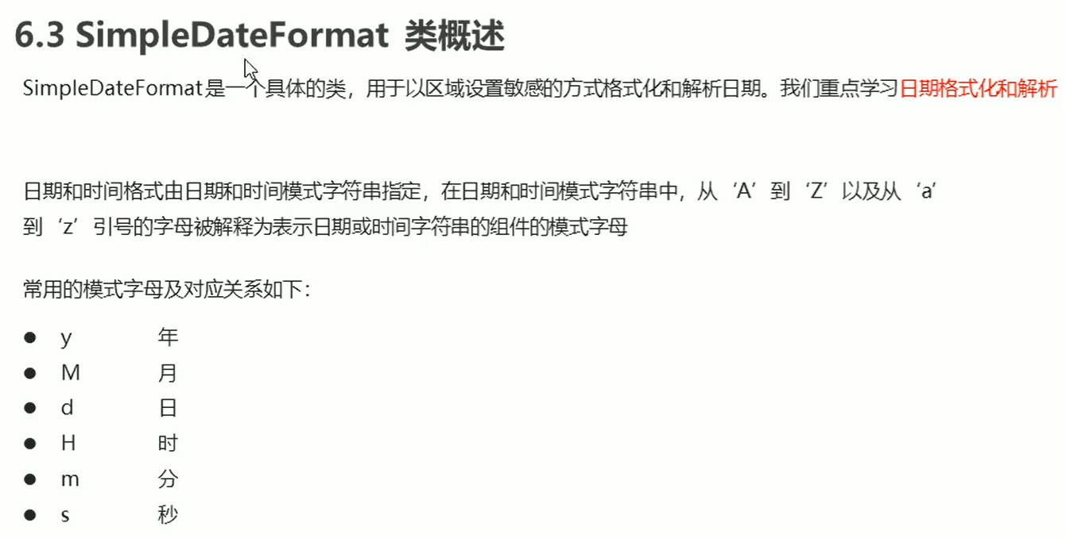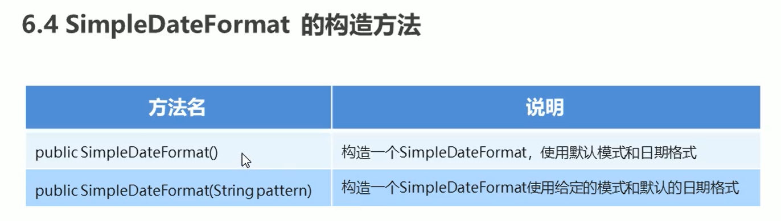

import java.text.ParseException;

import java.text.SimpleDateFormat;

import java.util.Date;

public class SimpleDateFormatDemo {

public static void main(String[] args) throws ParseException {

Date d = new Date();

SimpleDateFormat sdf = new SimpleDateFormat("yyyy年MM月dd日 HH:mm:ss");

String s = sdf.format(d);

System.out.println(s);

System.out.println("-------------");

String ss = "2022-08-04 12:51:20";

SimpleDateFormat sdf2 = new SimpleDateFormat("yyyy-MM-dd HH:mm:ss");

Date dd = sdf2.parse(ss);

System.out.println(dd);

}

}

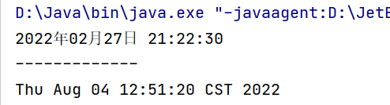

注意：中英文的冒号和空格不一样，会报错！

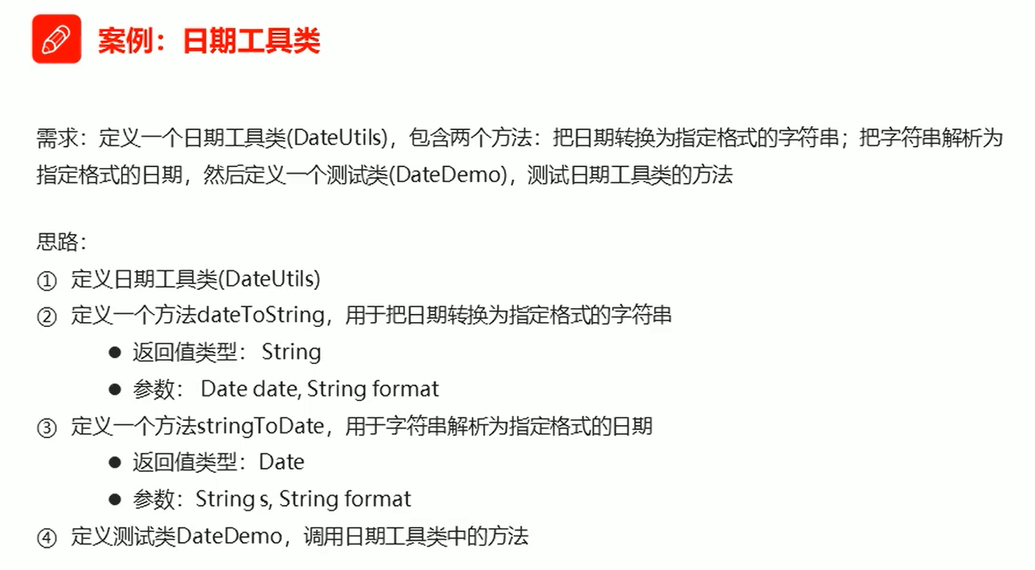

import java.text.ParseException;

import java.text.SimpleDateFormat;

import java.util.Date;

public class DateUtils {

private DateUtils() {

}

public static String dateToString(Date date, String format) {

SimpleDateFormat sdf = new SimpleDateFormat(format);

String s = sdf.format(date);

return s;

}

public static Date stringToDate(String s, String format) throws ParseException {

SimpleDateFormat sdf = new SimpleDateFormat(format);

Date d = sdf.parse(s);

return d;

}

}

import java.text.ParseException;

import java.util.Date;

public class DateDemo {

public static void main(String[] args) throws ParseException {

Date d = new Date();

String s0 = DateUtils.dateToString(d, "yyyy年MM月dd日 HH:mm:ss");

System.out.println(s0);

String s1 = DateUtils.dateToString(d, "yyyy年MM月dd日");

System.out.println(s1);

String s2 = DateUtils.dateToString(d, "HH:mm:ss");

System.out.println(s2);

System.out.println("-------------");

String s ="2048-08-04 12:15:45";

Date d1 = DateUtils.stringToDate(s, "yyyy-MM-dd HH:mm:ss");

System.out.println(d1);

}

}

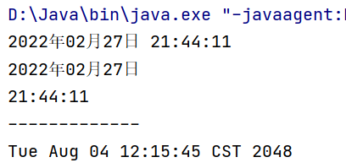

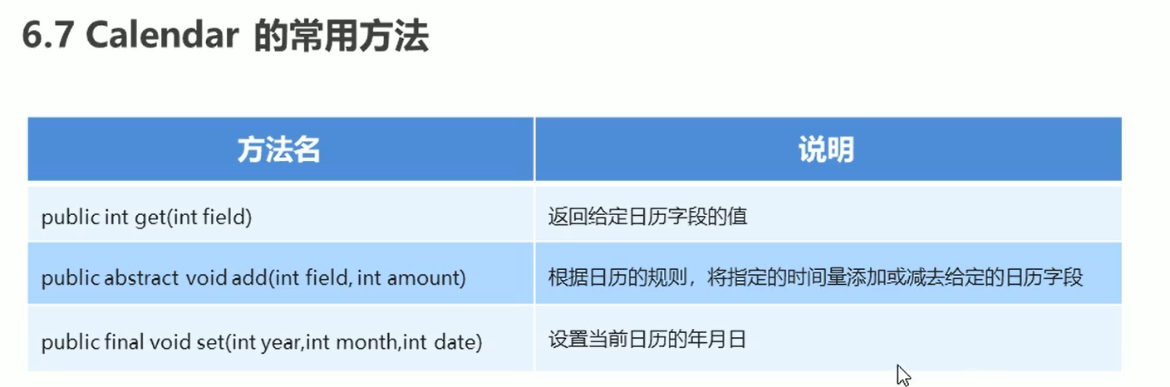

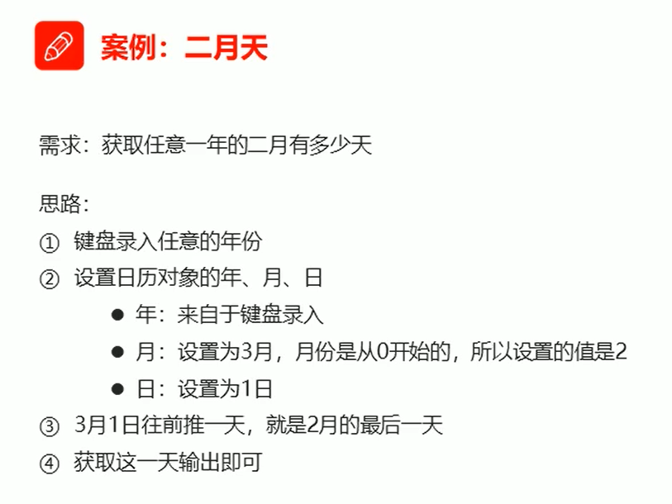

public class eryuetian {

public static void main(String[] args) {

Scanner sc = new Scanner(System.in);

System.out.println("请输入年份");

int year = sc.nextInt();

Calendar c = Calendar.getInstance();

c.set(year, 2, 1);

c.add(Calendar.DATE, -1);

int date = c.get(Calendar.DATE);

System.out.println(date);

System.out.println(year+"年的二月有"+date+"天");

}

}

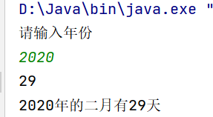

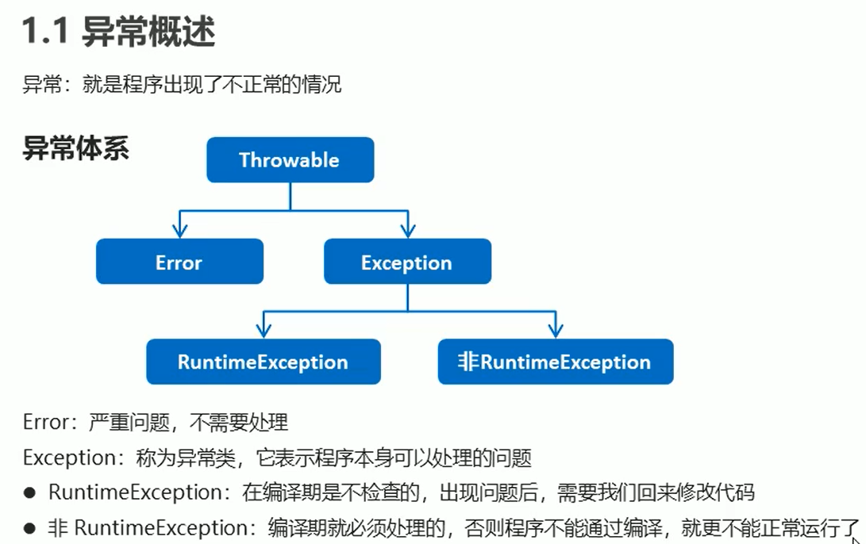

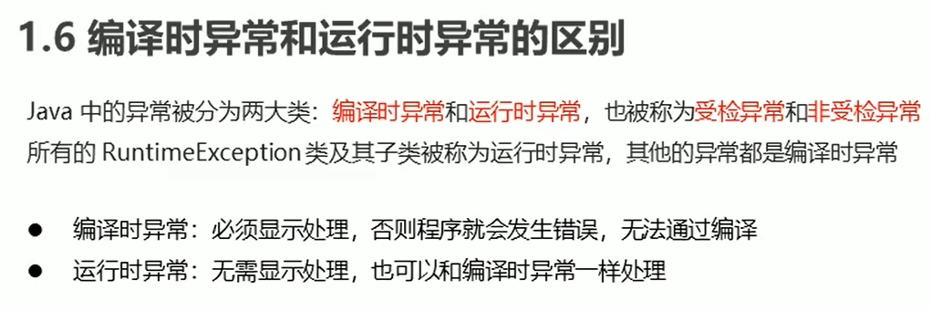

import java.text.ParseException;

import java.text.SimpleDateFormat;

import java.util.Date;

public class Demo1 {

public static void main(String[] args) {

method();

method2();

}

//编译时异常，不一定运行失败

public static void method2() {

try {

String s = "2048-08-04";

SimpleDateFormat sdf = new SimpleDateFormat("yyyy-MM-dd");

Date d = sdf.parse(s);

System.out.println(d);

} catch (ParseException E) {

E.printStackTrace();

}

}

//运行时异常

public static void method() {

try {

int arr[] = {1, 2, 3};

System.out.println(arr[3]);

} catch (ArrayIndexOutOfBoundsException e) {

e.printStackTrace();

}

}

}

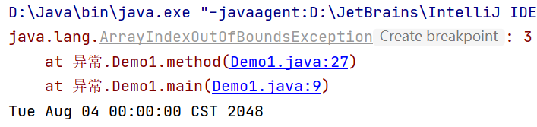

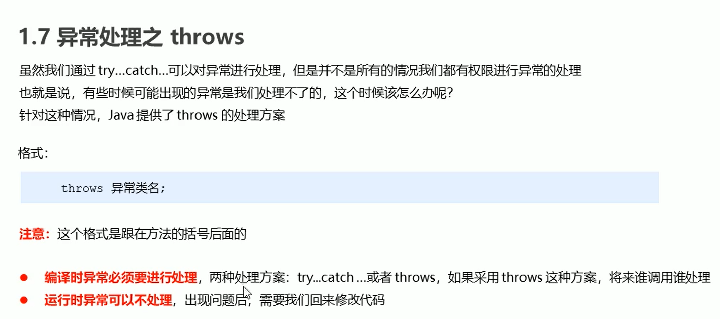

public class ScoreException extends Exception {

public ScoreException() {

}

public ScoreException(String message) {

super(message);

}

}

public class Teacher {

public void checkScore(int score) throws ScoreException{

if (score < 0 || score > 100) {

throw new ScoreException("你给的分数有误，应该在0-100之间");

} else {

System.out.println("分数正常");

}

}

}

public class test {

public static void main(String[] args) {

Scanner sc = new Scanner(System.in);

System.out.println("请输入分数");

int score = sc.nextInt();

Teacher t = new Teacher();

try {

t.checkScore(score);

} catch (ScoreException e) {

e.printStackTrace();

}

}

}

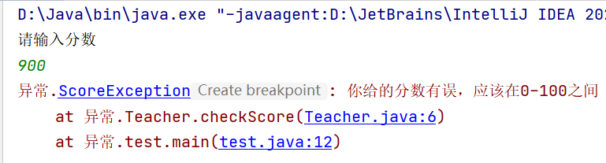

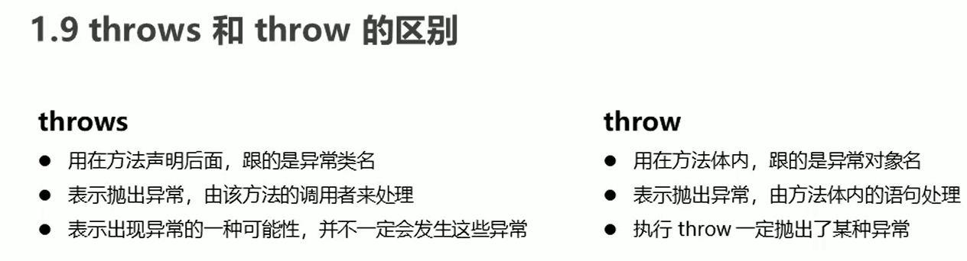

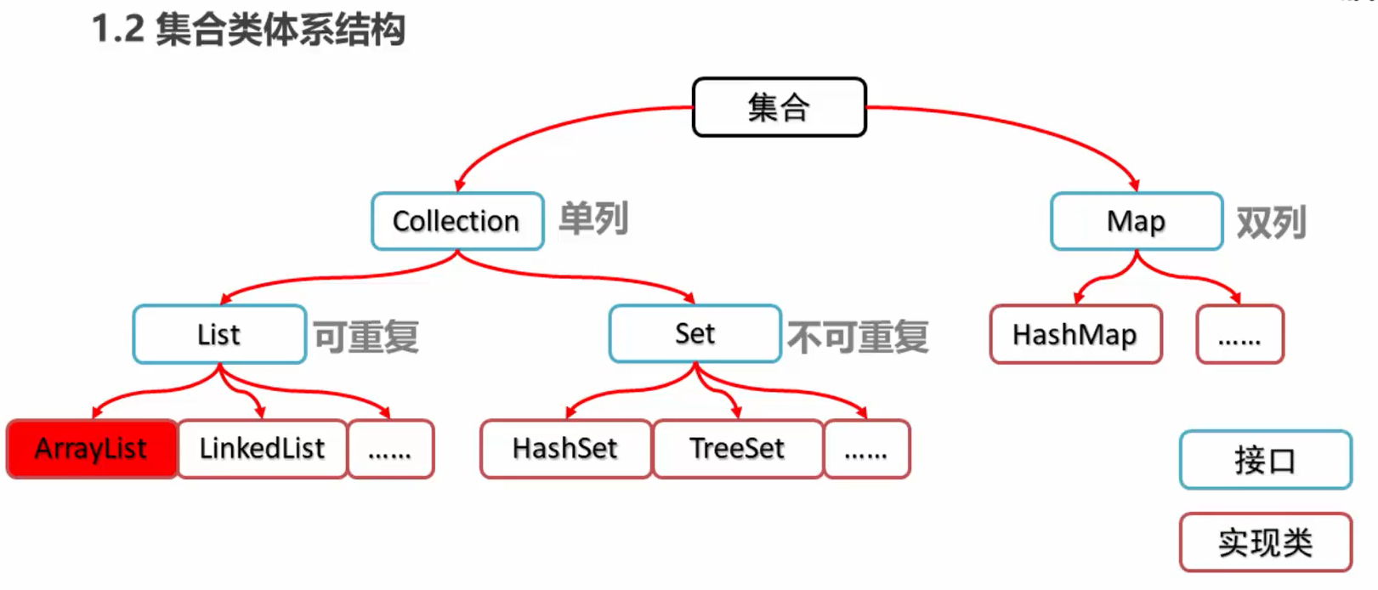

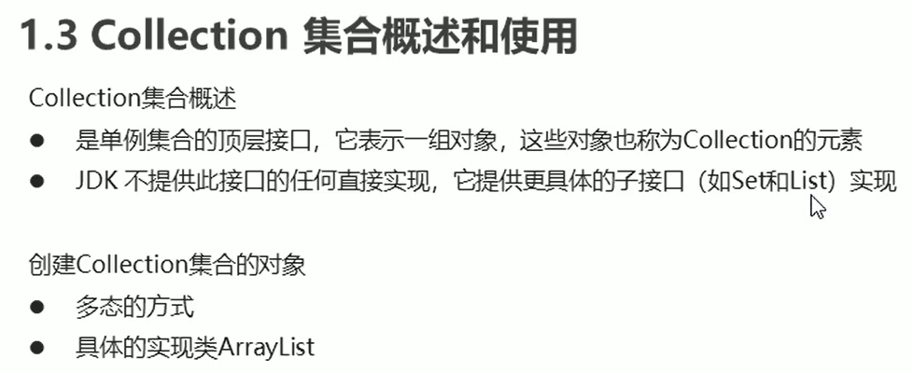

import java.util.ArrayList;

import java.util.Collection;

public class Demo {

public static void main(String[] args) {

Collection<String> c = new ArrayList<String>();

c.add("丁总");

c.add("林总");

c.add("小陈");

System.out.println(c);

}

}

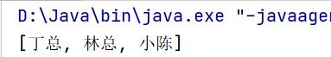

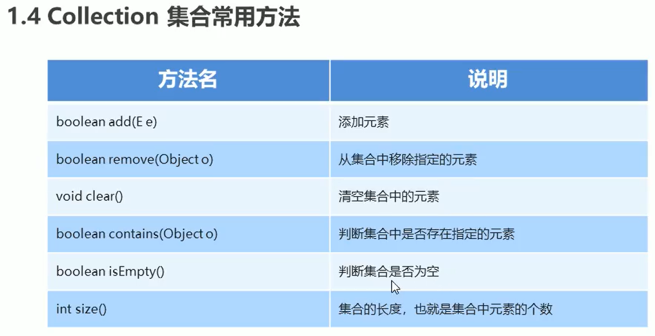

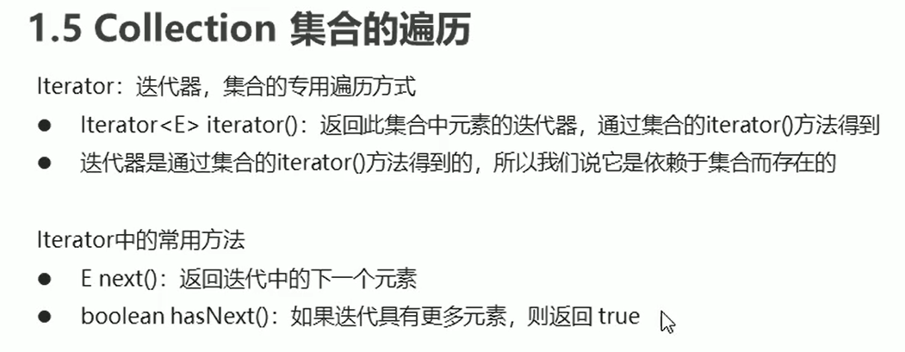

Collection的遍历

public class Demo {

public static void main(String[] args) {

Collection<String> c = new ArrayList<String>();

c.add("丁总");

c.add("林总");

c.add("小陈");

Iterator<String> it = c.iterator();

while (it.hasNext()) {

String s = it.next();

System.out.println(s);

}

}

}

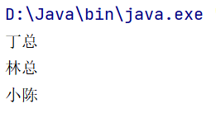



public class Demo {  
 public static void main(String[] args) {  
 Collection<Student> c = new ArrayList<Student>();  
 Student s1 = new Student("林总", 23);  
 Student s2 = new Student("丁总", 23);  
 Student s3 = new Student("小陈", 23);  
 c.add(s1);  
 c.add(s2);  
 c.add(s3);  
 Iterator<Student> it = c.iterator();  
 while (it.hasNext()) {  
 Student s = it.next();  
 System.out.println(s.getName()+s.getAge());  
 }  
 }  
}

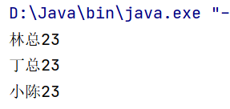

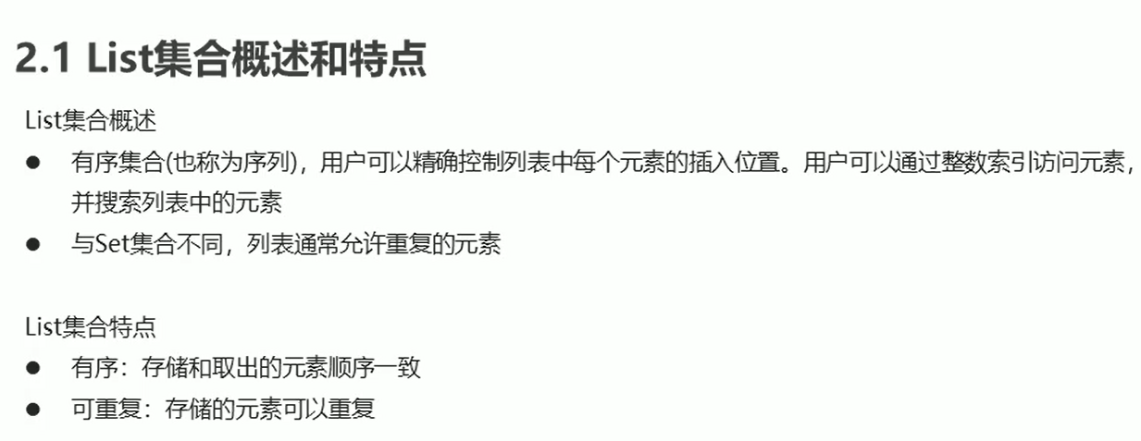

public class Demo {  
 public static void main(String[] args) {  
 List<Student> list = new ArrayList<Student>();  
 Student s1 = new Student("林总", 23);  
 Student s2 = new Student("丁总", 23);  
 Student s3 = new Student("小陈", 23);  
 list.add(s1);  
 list.add(s2);  
 list.add(s3);  
 Iterator<Student> it = list.iterator();  
 while (it.hasNext()) {  
 Student s = it.next();  
 System.out.println(s.getName() + s.getAge());  
 }  
 System.out.println("-----------");  
 for (int i = 0; i < list.size(); i++) {  
 Student s = list.get(i);  
 System.out.println(s.getName() + s.getAge());  
 }  
 }  
}

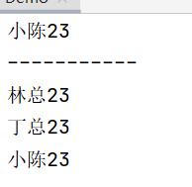

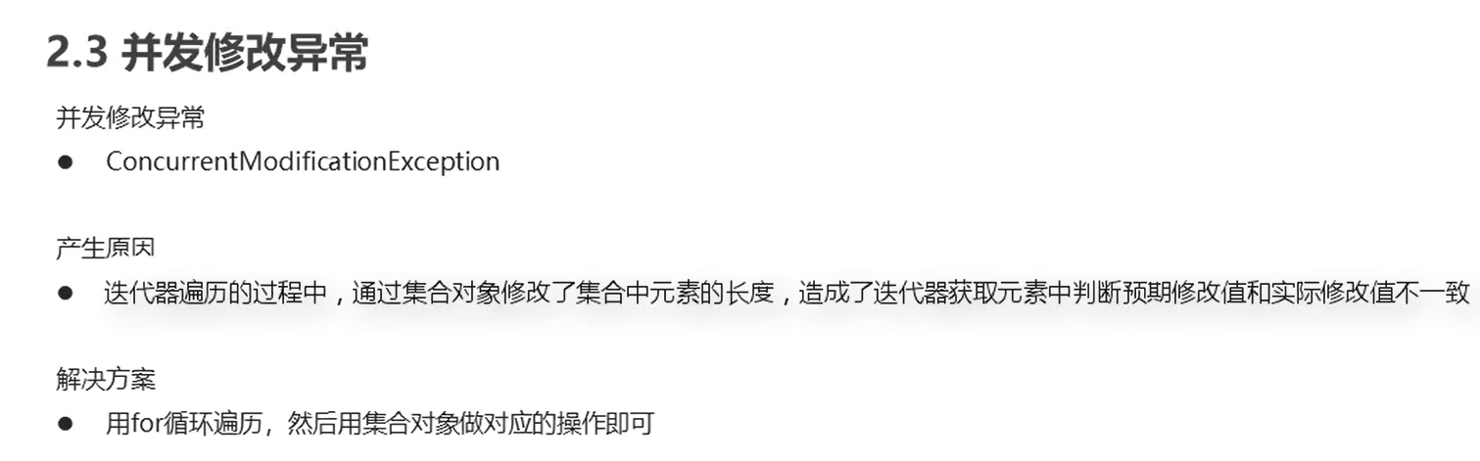

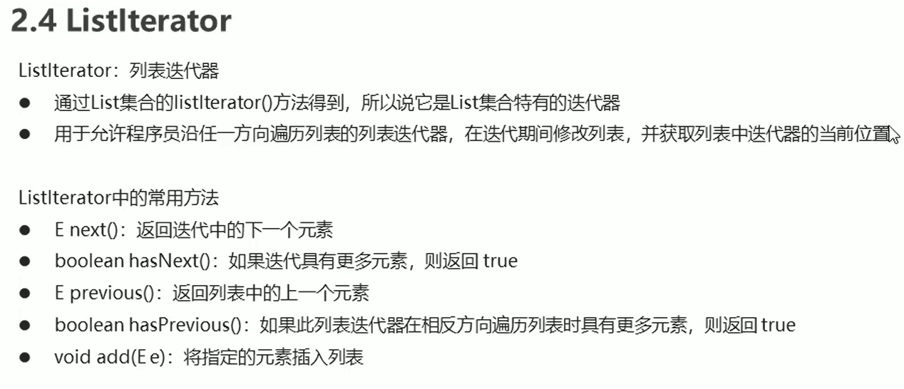

public class Demo {

public static void main(String[] args) {

List<String> list = new ArrayList<String>();

list.add("丁总");

list.add("林总");

list.add("小陈");

ListIterator<String> lit = list.listIterator();

while (lit.hasNext()) {

String s = lit.next();

if (s.equals("小陈")) {

lit.add("丁总的爹");

}

}

System.out.println(list);

}

}

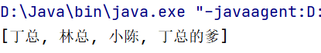

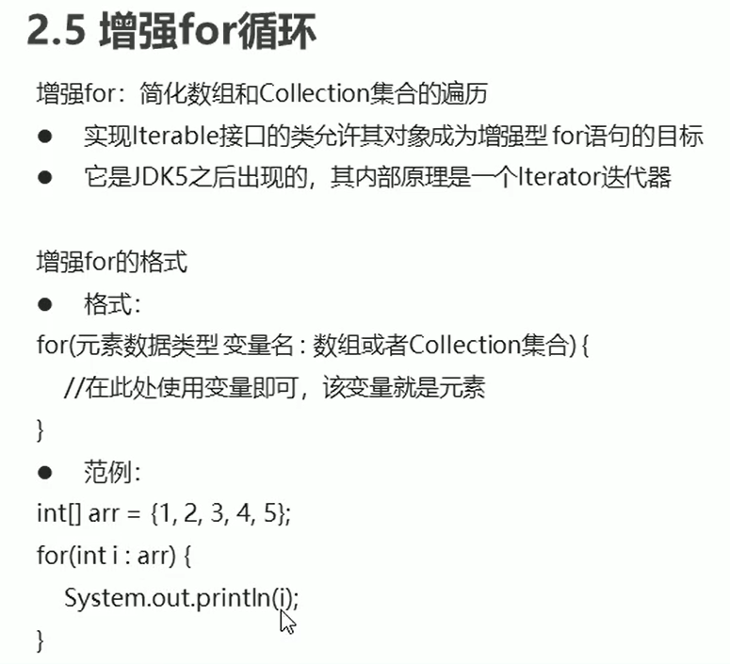

public class Demo {

public static void main(String[] args) {

int[] arr = {1, 2, 3, 4, 5};

for (int i : arr) {

System.out.println(i);

}

System.out.println("------------");

String[] arr2 = {"hello", "World"};

for (String s : arr2) {

System.out.println(s);

}

System.out.println("------------");

List<String> list = new ArrayList<String>();

list.add("丁总");

list.add("林总");

list.add("小陈");

for (String s2 : list) {

if (s2.equals("小陈")){

list.add("丁总的爹爹");

}

}

}

}

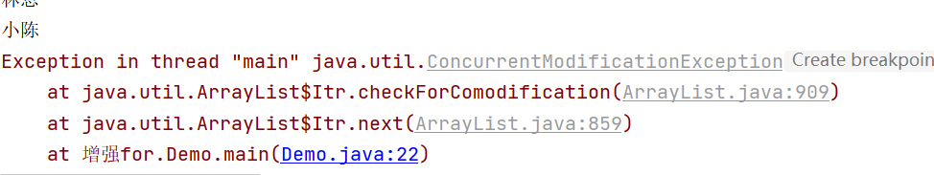

增强for的内部是一个Iterator迭代器。

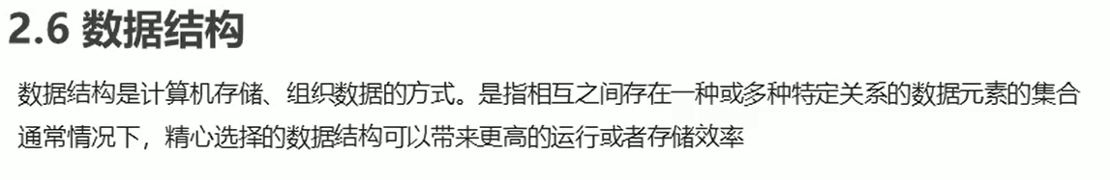

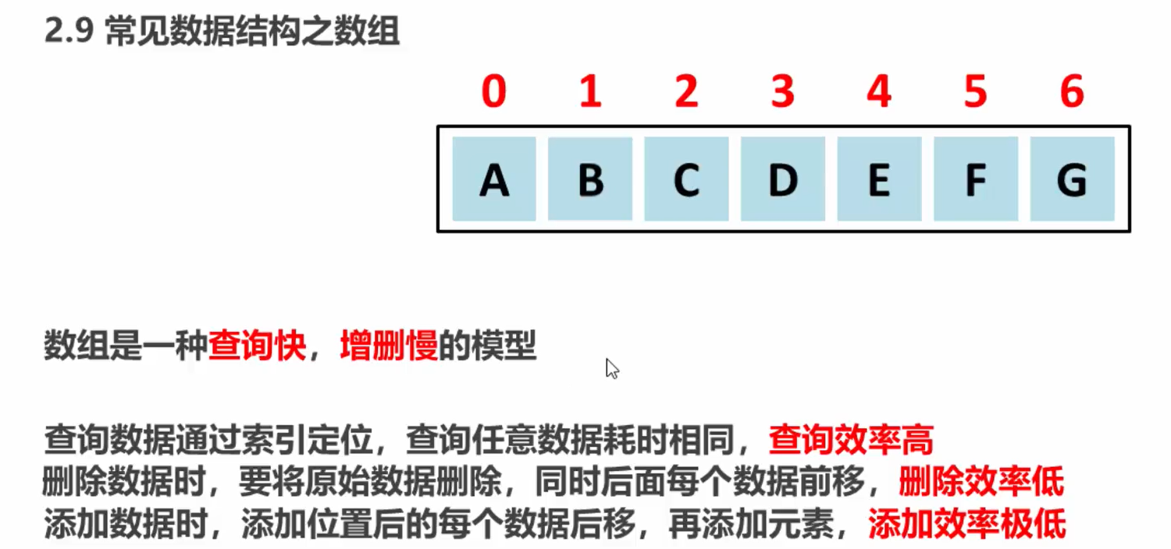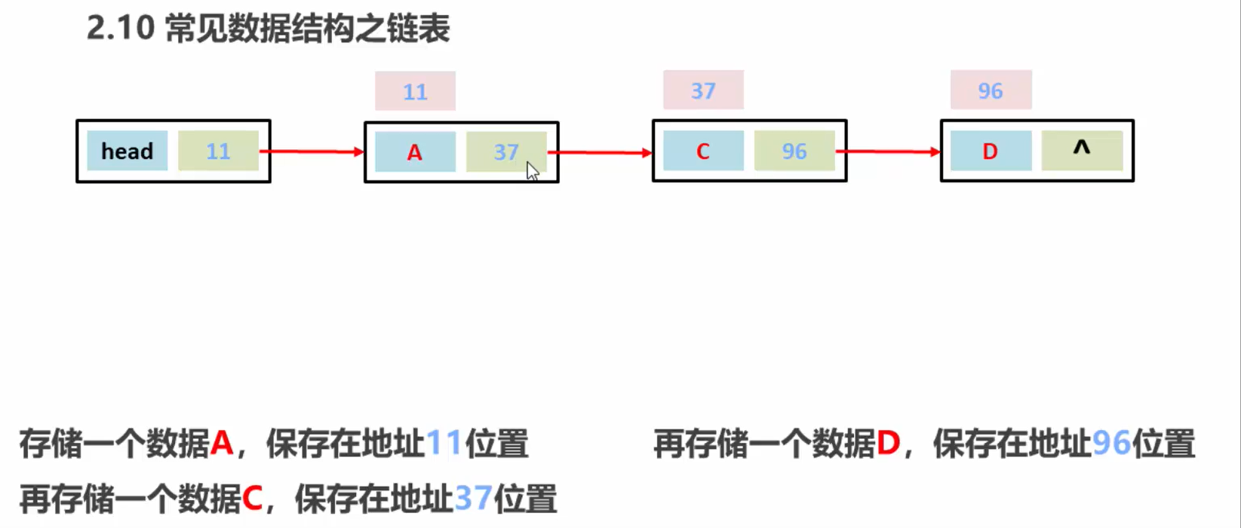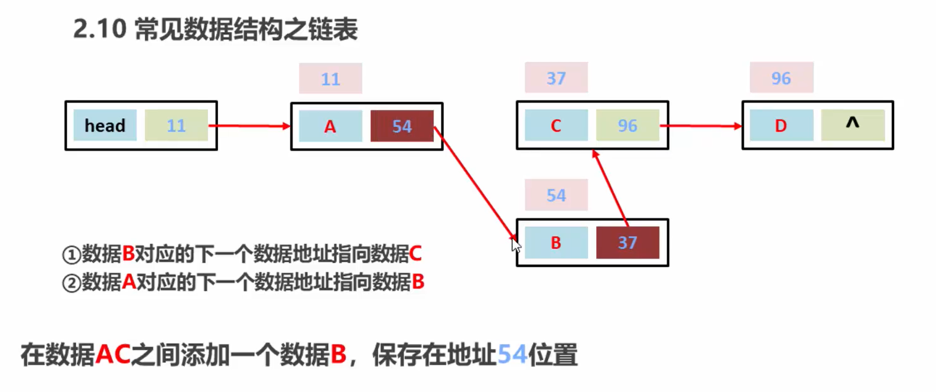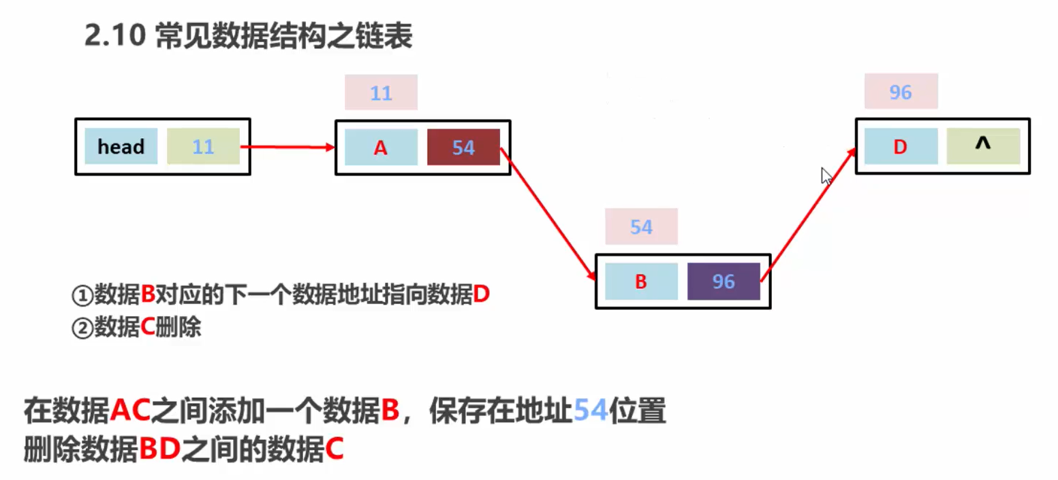

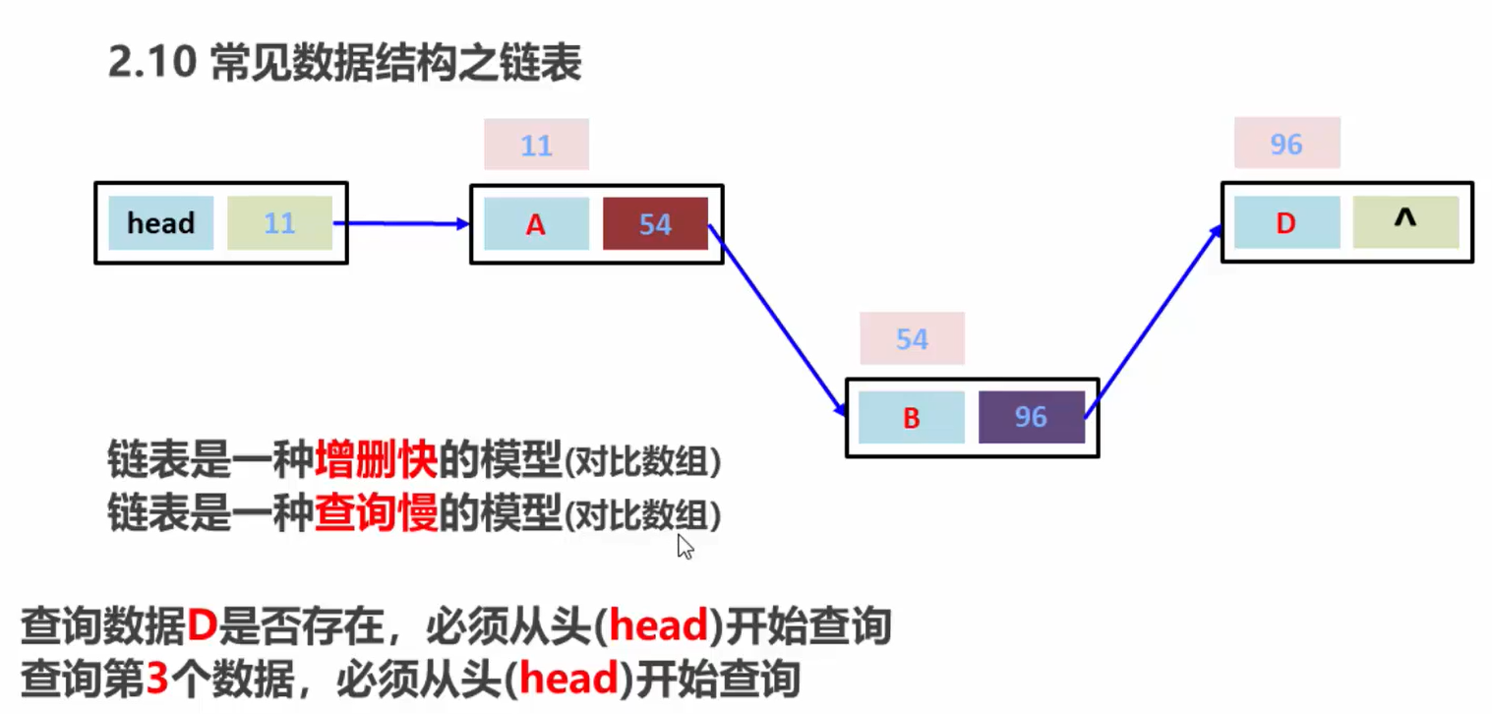



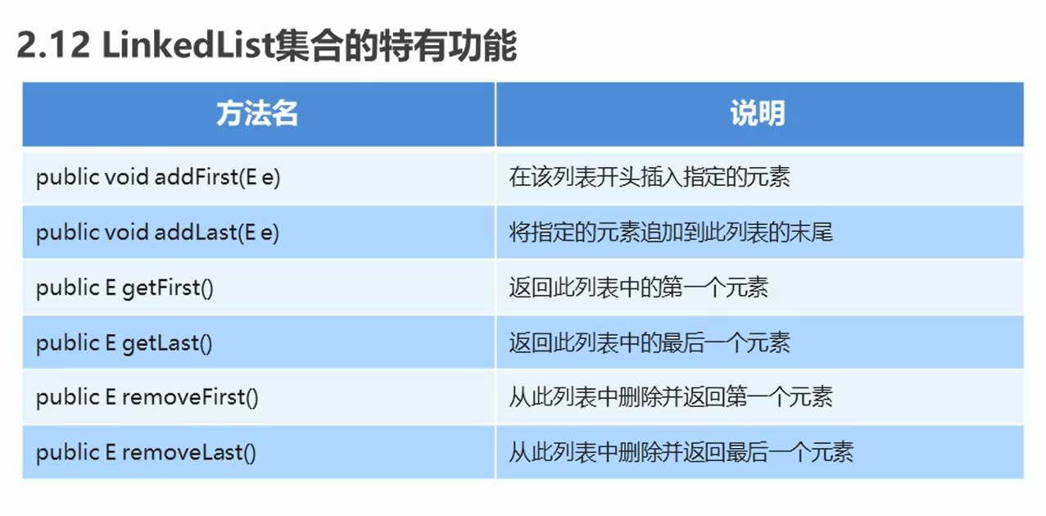

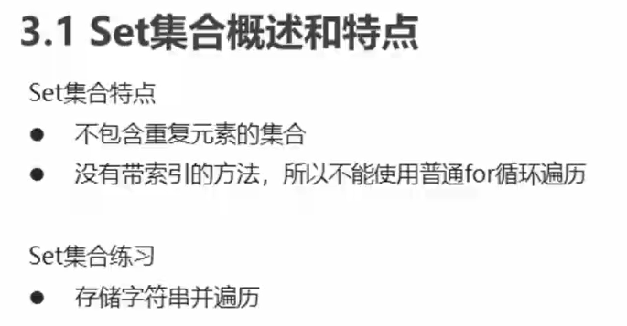

public class Demo {

public static void main(String[] args) {

Set<String> set = new HashSet<String>();

set.add("丁总");

set.add("林总");

set.add("小陈");

for (String s : set) {

System.out.println(s);

}

}

}

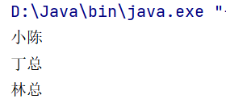

public static void main(String[] args) {

Student s1 = new Student("陈嘉明",23);

Student s2 = new Student("陈嘉明",23);

System.out.println(s1.hashCode());

System.out.println("丁总".hashCode());//643674

System.out.println("林总".hashCode());//846724

System.out.println("重地".hashCode());//1179395

System.out.println("通话".hashCode());//1179395

}

}

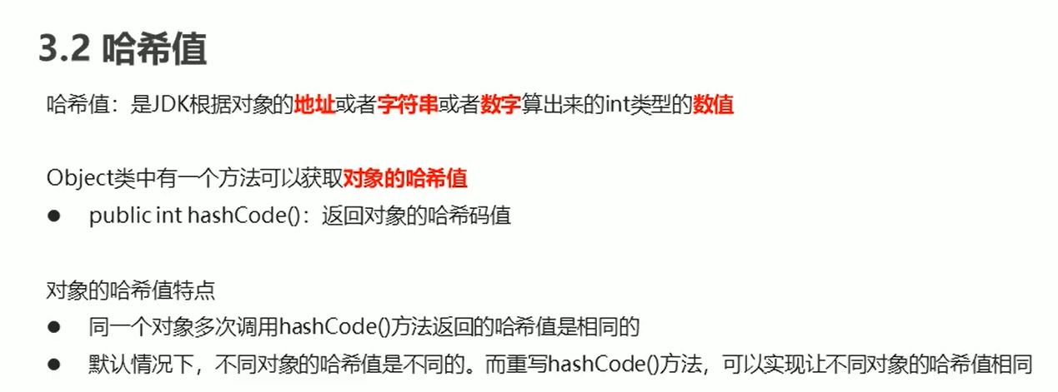

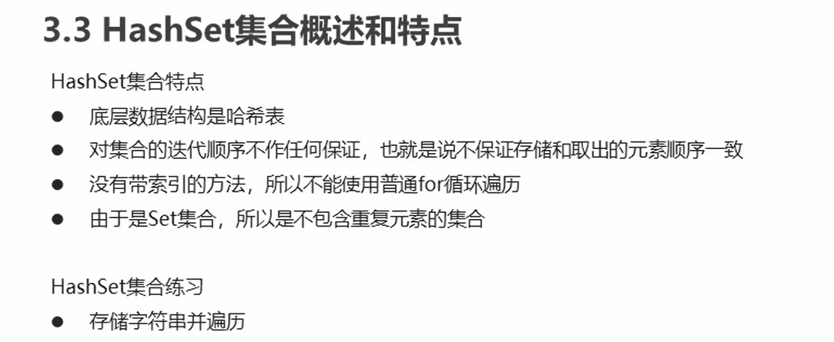

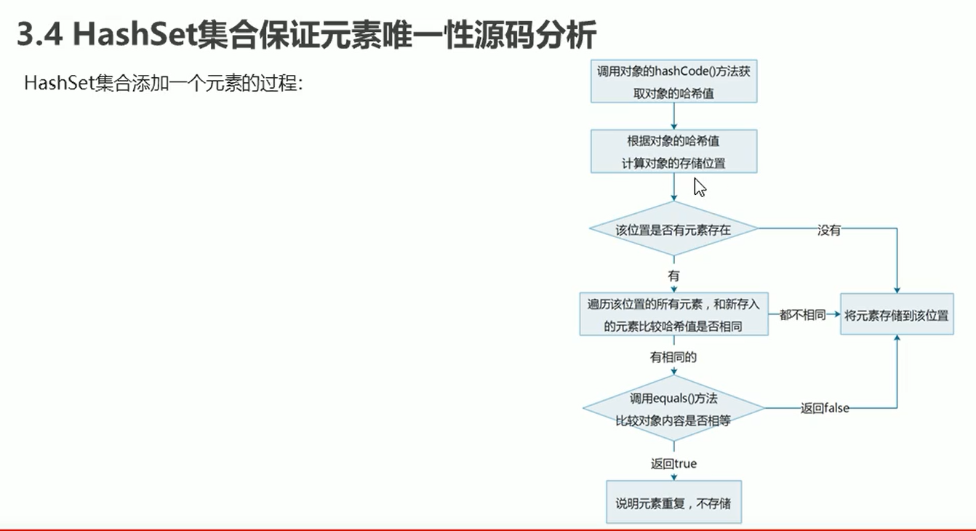

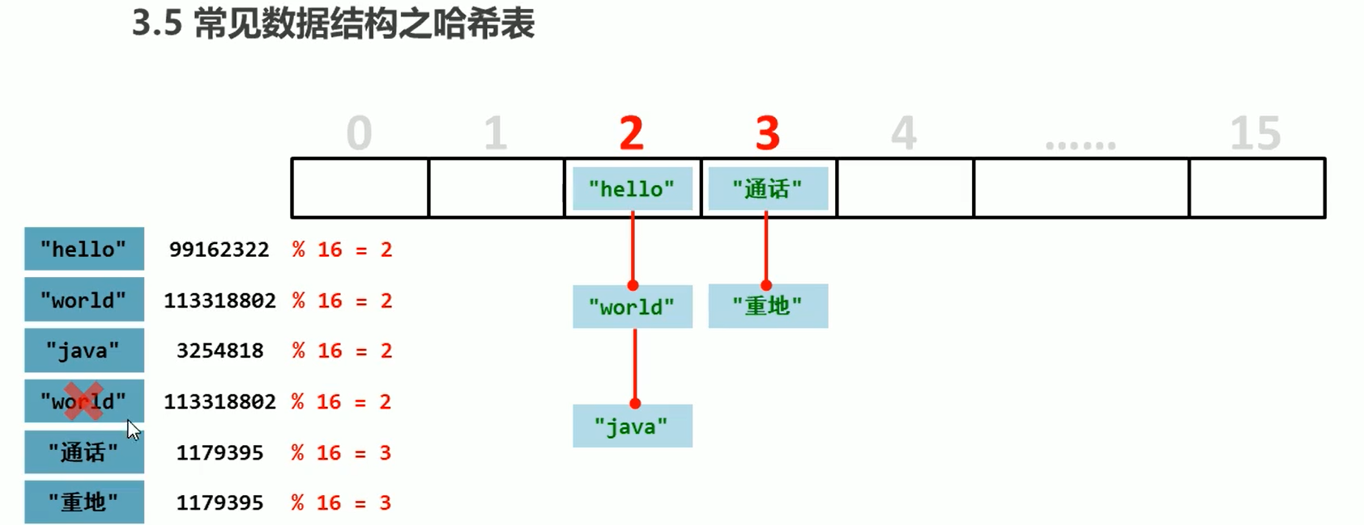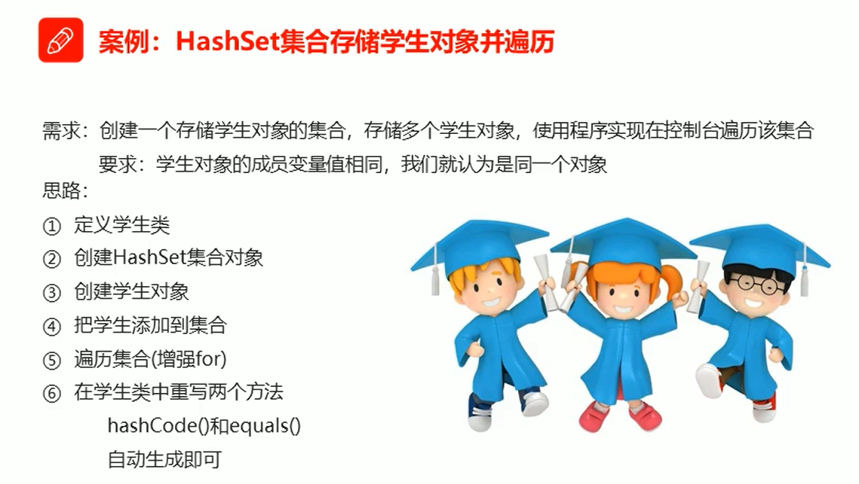

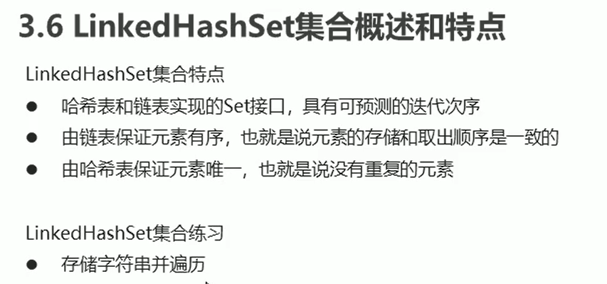

public class Demo {

public static void main(String[] args) {

LinkedHashSet<String> linkedHashSet = new LinkedHashSet<String>();

linkedHashSet.add("丁总");

linkedHashSet.add("林总");

linkedHashSet.add("小陈");

for (String s : linkedHashSet) {

System.out.println(s);

}

}

}

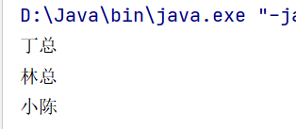

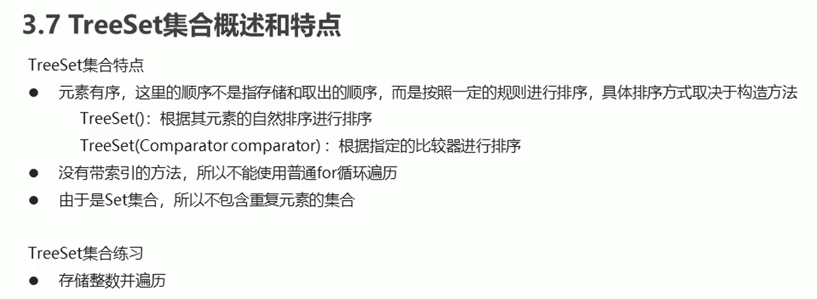

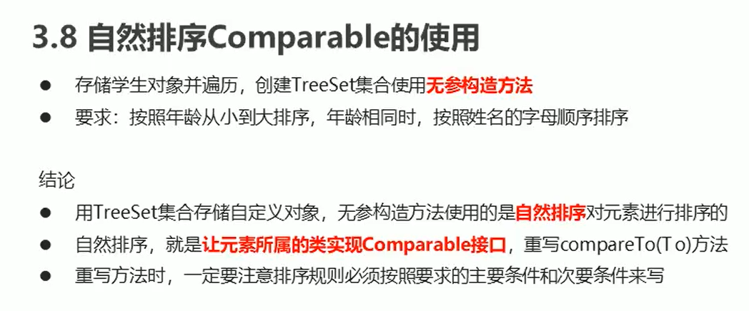

public class Demo {

public static void main(String[] args) {

TreeSet<Student> ts = new TreeSet<Student>();

Student s1 = new Student("xiaochen", 23);

Student s2 = new Student("dingzong", 24);

Student s3 = new Student("linzong", 23);

ts.add(s1);

ts.add(s2);

ts.add(s3);

for (Student s : ts) {

System.out.println(s.getName()+","+s.getAge()+"岁");

}

}

}

public class Student implements Comparable<Student>

@Override

public int compareTo(Student s) {

int num = this.age - s.age;

int num2 = num == 0? this.name.compareTo(s.name):num;

return num2;

}

}

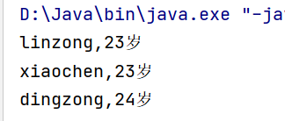

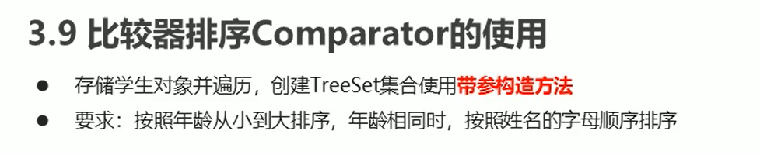

public class Demo {

public static void main(String[] args) {

TreeSet<Student> ts = new TreeSet<Student>(new Comparator<Student>() {

@Override

public int compare(Student s1, Student s2) {

int num = s1.getAge() - s2.getAge();

int num2 = num == 0 ? s1.getName().compareTo(s2.getName()) : num;

return num2;

}

});

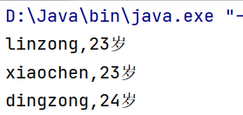

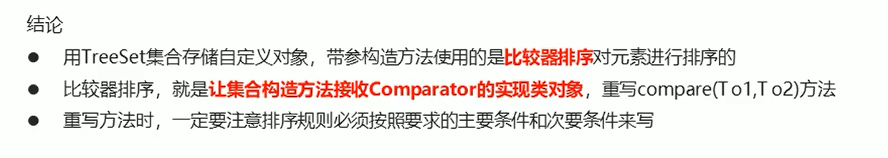

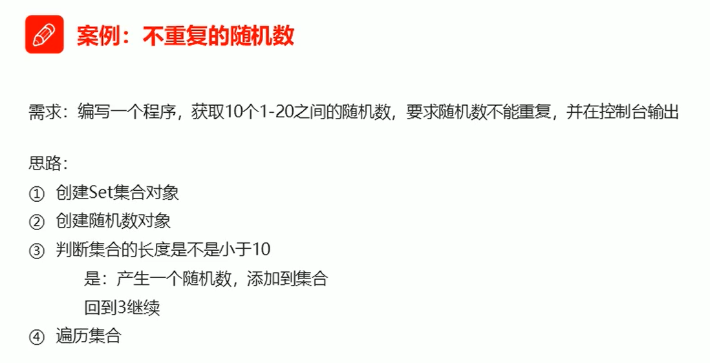

public class Demo {  
 public static void main(String[] args) {  
 Set<Integer> set = new HashSet<>();  
 Random r = new Random();  
 while (set.size() < 10) {  
 int number = r.nextInt(20) + 1;  
 set.add(number);  
 }  
 for (Integer i : set) {  
 System.out.println(i);  
 }  
 }  
}

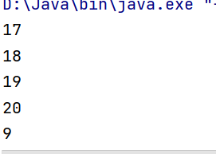

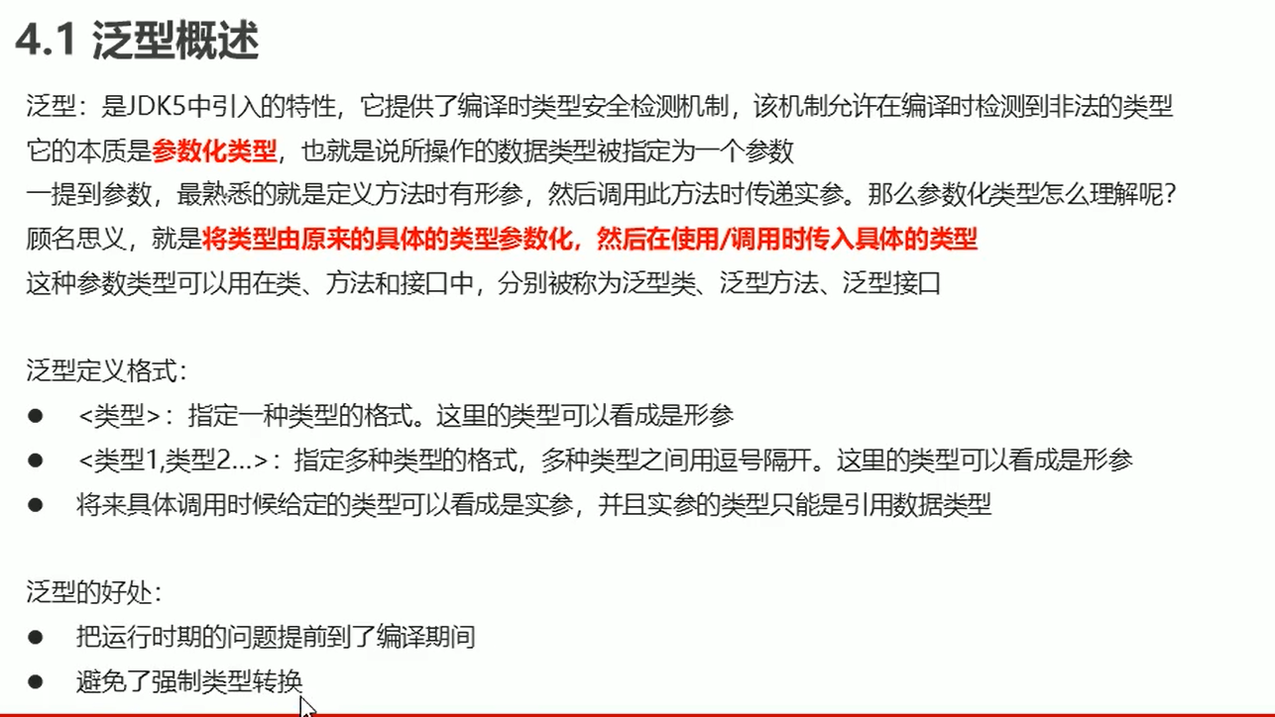

泛型类

public class Generic<T> {  
 private T t;  
 public T getT() {  
 return t;  
 }  
 public void setT(T t) {  
 this.t = t;  
 }  
}

public class Demo {  
 public static void main(String[] args) {  
 Generic<String> g1 = new Generic<String>();  
 g1.setT("陈嘉明");  
 System.out.println(g1.getT());  
 Generic<Integer> g2 = new Generic<Integer>();  
 g2.setT(23);  
 System.out.println(g2.getT());  
 }  
}

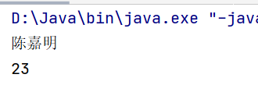

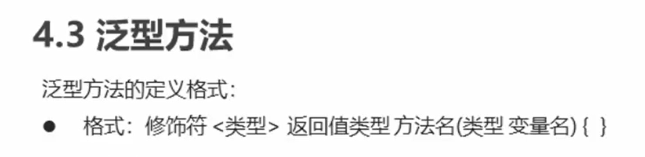

public class Generic {

public <T> void show(T t) {

System.out.println(t);

}

}

public class Demo {  
 public static void main(String[] args) {  
 Generic g = new Generic();  
 g.show("陈嘉明");  
 g.show(26);  
 g.show(12.34);  
 }  
}

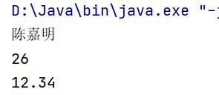

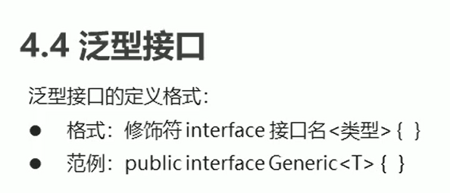

public interface Generic <T>{

void show (T t);

}

public class Genericimpl <T> implements Generic<T>{

@Override

public void show(T t) {

System.out.println(t);

}

}

public class Demo {

public static void main(String[] args) {

Generic<String> g1 = new Genericimpl<String>();

g1.show("陈嘉明");

Generic<Integer> g2 = new Genericimpl<Integer>();

g2.show(26);

}

}

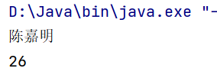

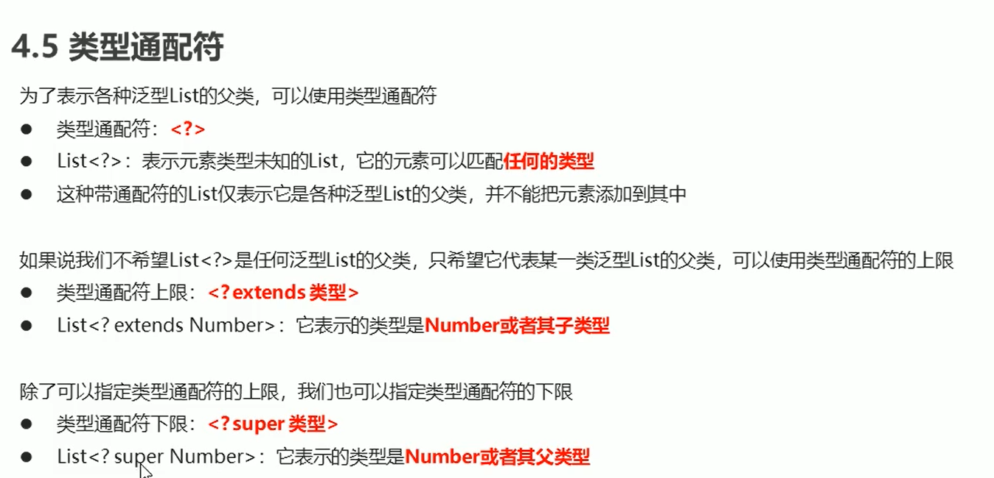

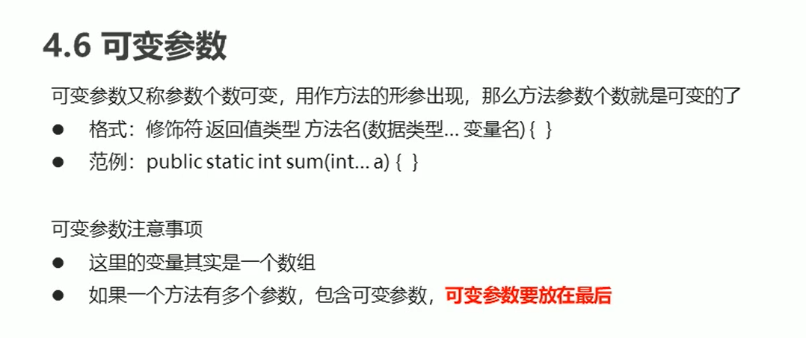

public class Demo {

public static void main(String[] args) {

System.out.println(sum(10,20,30,50,40));

System.out.println(sum(10,50,30,50,40,80));

}

public static int sum (int...a){

int sum = 0;

for (int i : a){

sum += i;

}

return sum;

}

}

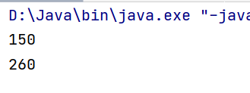

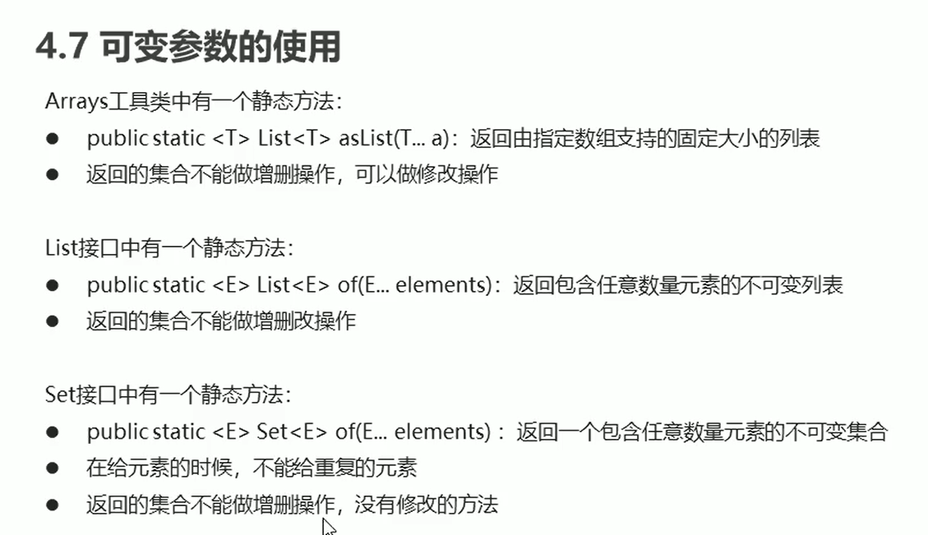

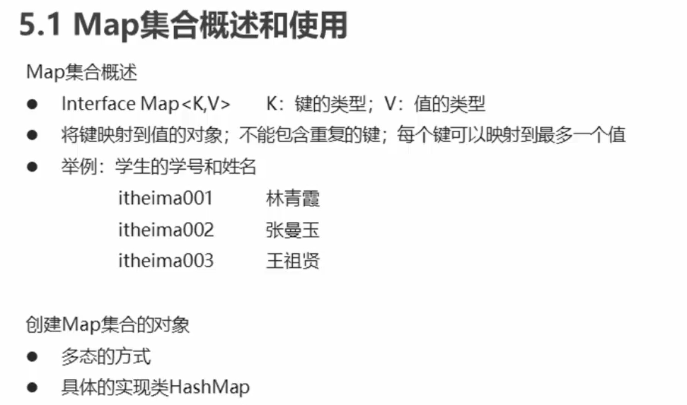

import java.util.HashMap;

import java.util.Map;

public class Demo {

public static void main(String[] args) {

Map<String,String> map = new HashMap<String,String>();

map.put("21","小陈");

map.put("22","丁总");

map.put("23","林总");

System.out.println(map);

}

}

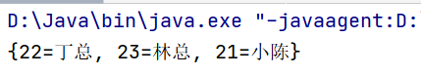

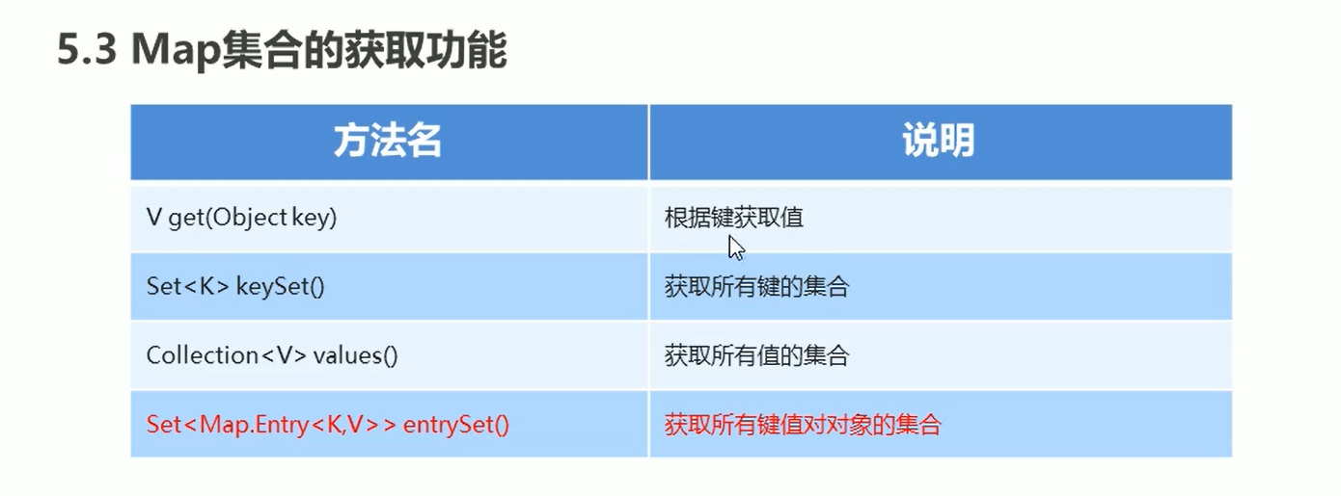

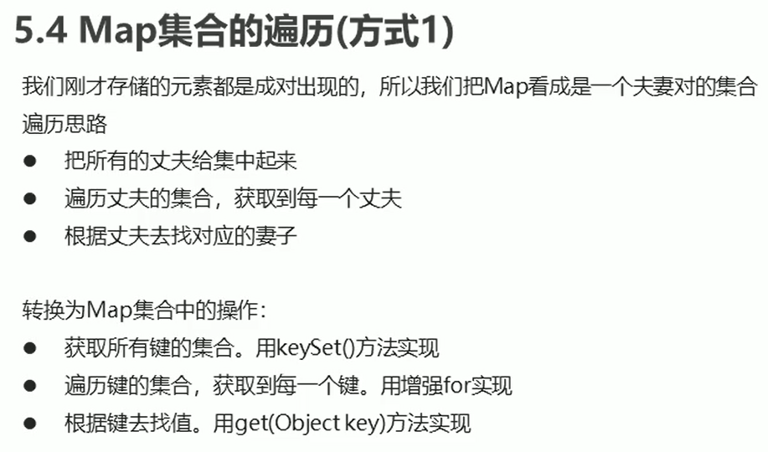

public class Demo {

public static void main(String[] args) {

Map<String, String> map = new HashMap<String, String>();

map.put("杨过", "小龙女");

map.put("郭靖", "黄蓉");

map.put("张无忌", "赵敏");

Set<String> keySet = map.keySet();

for (String key : keySet) {

String value = map.get(key);

System.out.println(key + "," + value);

}

}

}

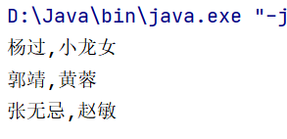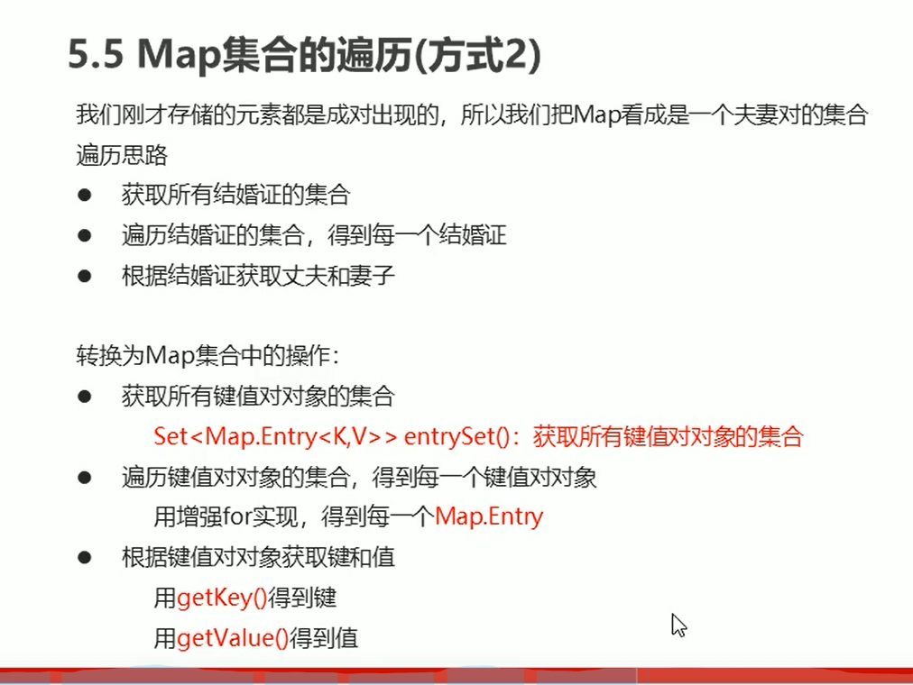

public class Demo {

public static void main(String[] args) {

Map<String, String> map = new HashMap<String, String>();

map.put("杨过", "小龙女");

map.put("郭靖", "黄蓉");

map.put("张无忌", "赵敏");

Set<Map.Entry<String, String>> entrySet = map.entrySet();

for (Map.Entry<String, String> me : entrySet) {

String key = me.getKey();

String value = me.getValue();

System.out.println(key + "," + value);

}

}

}

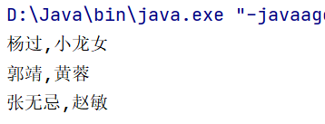

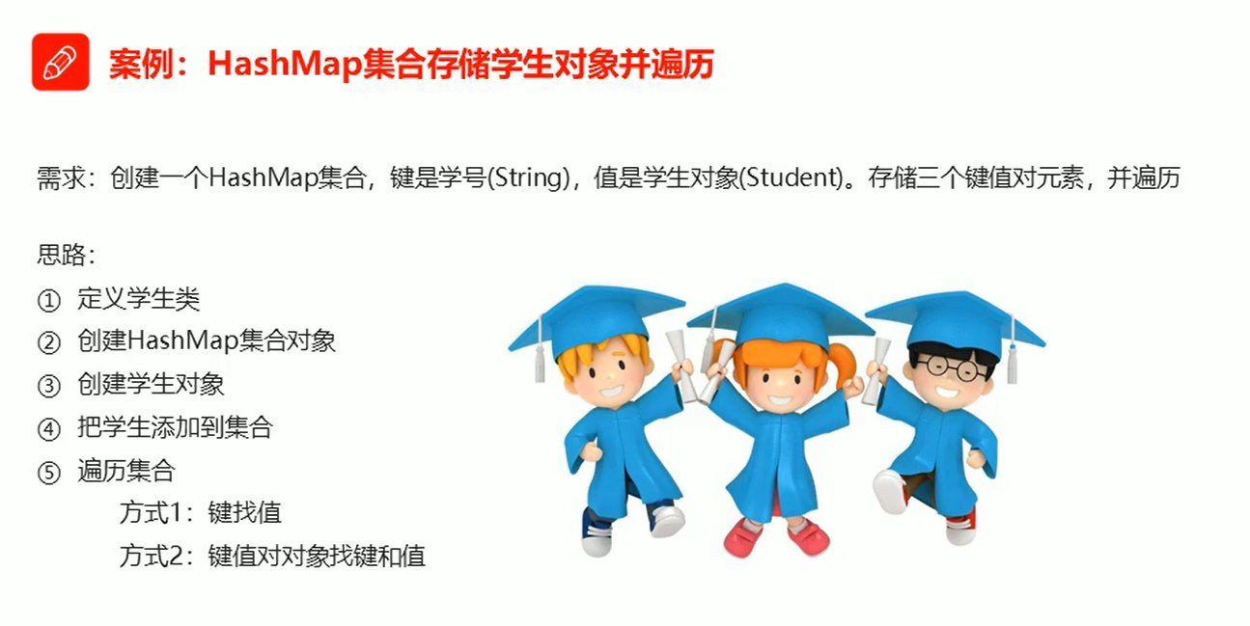

public class Demo {

public static void main(String[] args) {

HashMap<String, Student> hm = new HashMap<String, Student>();

Student s1 = new Student("丁总", 23);

Student s2 = new Student("林总", 24);

Student s3 = new Student("小陈", 22);

hm.put("123", s1);

hm.put("456", s2);

hm.put("789", s3);

Set<String> keySet = hm.keySet();

for (String key : keySet) {

Student value = hm.get(key);

System.out.println(key + "," + value.getName() + "," + value.getAge() + "岁");

}

System.out.println("---------");

Set<Map.Entry<String, Student>> entrySet = hm.entrySet();

for (Map.Entry<String, Student> me : entrySet) {

String key = me.getKey();

Student value = me.getValue();

System.out.println(key + "," + value.getName() + "," + value.getAge() + "岁");

}

}

}

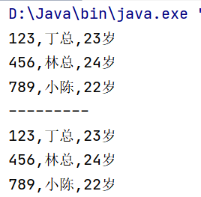

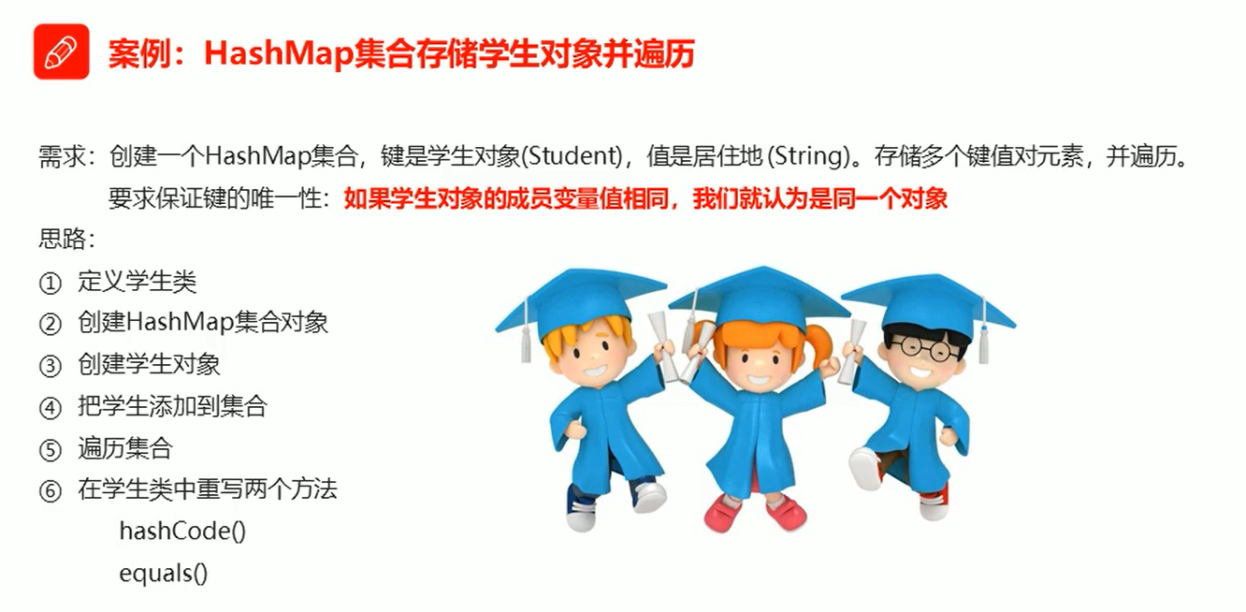

public class Demo {

public static void main(String[] args) {

HashMap<Student, String> hm = new HashMap<Student, String>();

Student s1 = new Student("丁总", 23);

Student s2 = new Student("林总", 23);

Student s3 = new Student("小陈", 23);

hm.put(s1, "深圳湾壹号");

hm.put(s2, "侨鑫汇悦台");

hm.put(s3, "蓬江大桥底");

Set<Student> keySet = hm.keySet();

for (Student key : keySet) {

String value = hm.get(key);

System.out.println(key.getName() + "," + key.getAge() + "岁" + value);

}

System.out.println("---------");

Set<Map.Entry<Student,String>> entrySet = hm.entrySet();

for (Map.Entry<Student,String > me : entrySet) {

Student key = me.getKey();

String value = me.getValue();

System.out.println(key.getName() + "," + key.getAge() + "岁" + value);

}

}

}

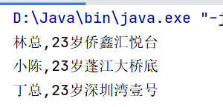

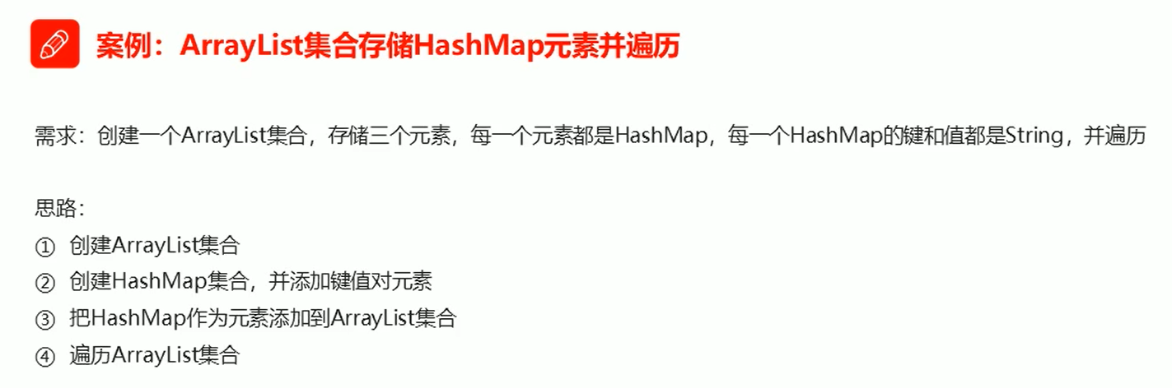

public class Demo {

public static void main(String[] args) {

ArrayList<HashMap<String, String>> array = new ArrayList<HashMap<String, String>>();

HashMap<String, String> hm1 = new HashMap<String, String>();

hm1.put("丁总", "23");

hm1.put("深圳湾一号", "1000平");

array.add(hm1);

HashMap<String, String> hm2 = new HashMap<String, String>();

hm2.put("林总", "23");

hm2.put("侨鑫汇悦台", "500平");

array.add(hm2);

HashMap<String, String> hm3 = new HashMap<String, String>();

hm3.put("小陈", "23");

hm3.put("蓬江大桥底", "5平");

array.add(hm3);

for (HashMap<String, String> hm : array) {

Set<String> keySet = hm.keySet();

for (String key : keySet) {

String value = hm.get(key);

System.out.println(key + "," + value);

}

}

}

}

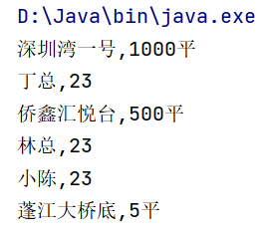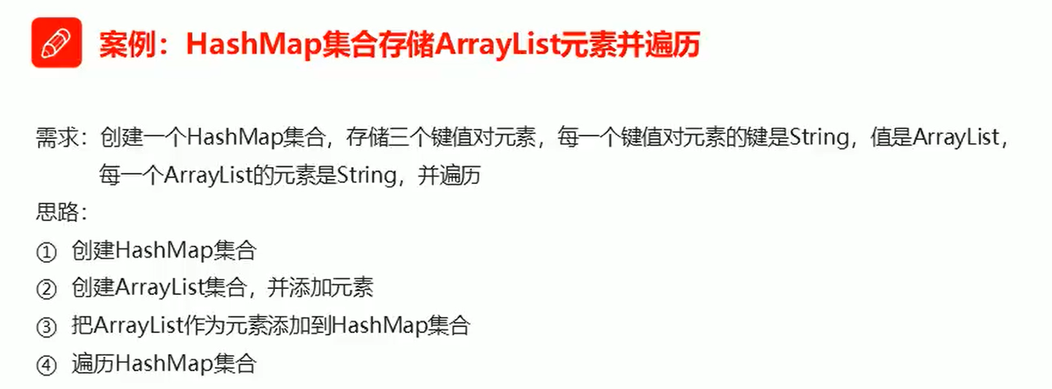

public class Demo {

public static void main(String[] args) {

HashMap<String, ArrayList<String>> hm = new HashMap<String, ArrayList<String>>();

ArrayList<String> sjh = new ArrayList<String>();

sjh.add("sjy");

sjh.add("sjz");

hm.put("sj会", sjh);

ArrayList<String> fqb = new ArrayList<String>();

fqb.add("shit");

fqb.add("asshole");

hm.put("福泉帮", fqb);

ArrayList<String> tencent = new ArrayList<String>();

tencent.add("ceisten");

tencent.add("valueMachine");

hm.put("腾讯", tencent);

Set<String> keySet = hm.keySet();

for (String key : keySet) {

System.out.println(key);

ArrayList<String> value = hm.get(key);

for (String s : value) {

System.out.println("\t" + s);

}

}

}

}

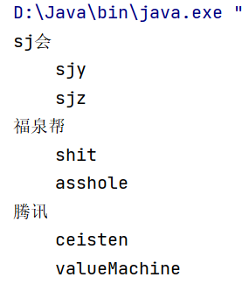

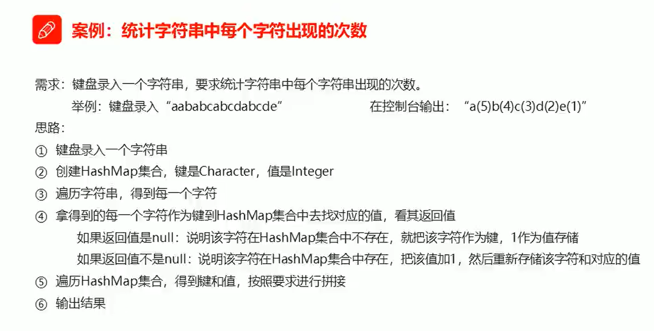

public class Demo {

public static void main(String[] args) {

Scanner sc = new Scanner(System.in);

System.out.println("请输入一个字符串");

String line = sc.nextLine();

TreeMap<Character, Integer> hm = new TreeMap<Character, Integer>();

for (int i = 0; i < line.length(); i++) {

char key = line.charAt(i);

Integer value = hm.get(key);

if (value == null) {

hm.put(key, 1);

} else {

value++;

hm.put(key, value);

}

}

StringBuilder sb = new StringBuilder();

Set<Character> keySet = hm.keySet();

for (Character key : keySet) {

Integer value = hm.get(key);

sb.append(key).append("(").append(value).append(")");

}

String result = sb.toString();

System.out.println(result);

}

}

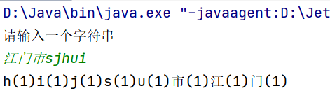

用TreeMap可以对字符字母进行排序

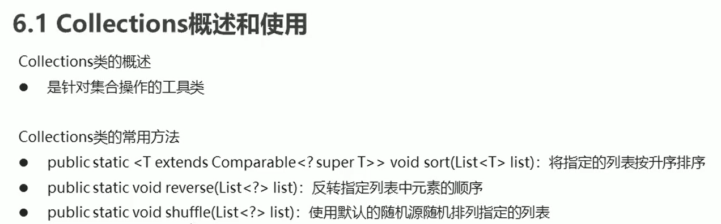

public class Demo {

public static void main(String[] args) {

List<Integer> list = new ArrayList<Integer>();

list.add(10);

list.add(60);

list.add(30);

list.add(50);

list.add(80);

Collections.sort(list);

System.out.println(list);

Collections.reverse(list);

System.out.println(list);

Collections.shuffle(list);

System.out.println(list);

}

}

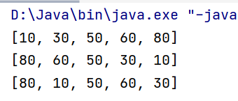

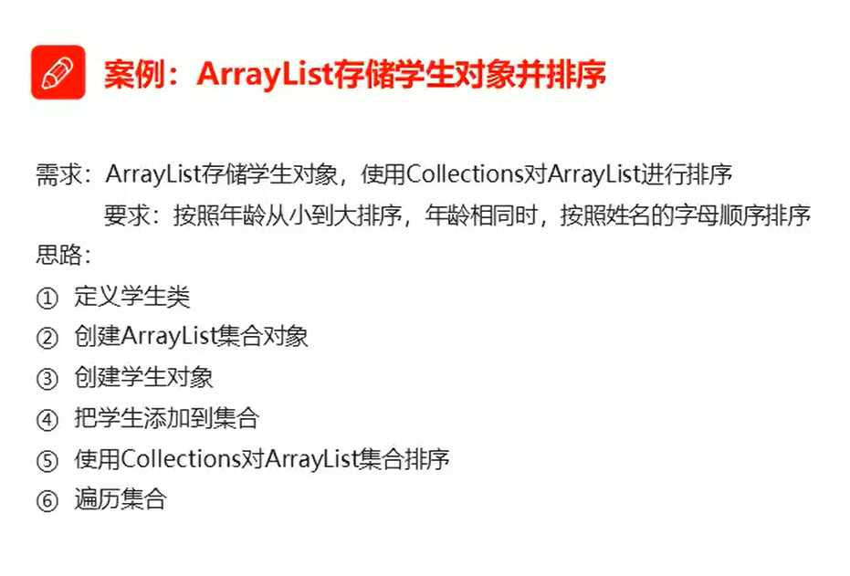

public class Demo {

public static void main(String[] args) {

ArrayList<Student> array = new ArrayList<Student>();

Student s1 = new Student("丁总", 23);

Student s2 = new Student("林总", 24);

Student s3 = new Student("小陈", 22);

array.add(s1);

array.add(s2);

array.add(s3);

Collections.sort(array, new Comparator<Student>() {

@Override

public int compare(Student s1, Student s2) {

int num = s1.getAge() - s2.getAge();

int num2 = num == 0 ? s1.getName().compareTo(s2.getName()) : num;

return num2;

}

});

for (Student s: array){

System.out.println(s.getName()+","+s.getAge());

}

}

}

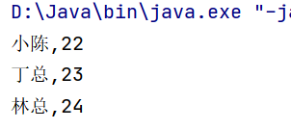

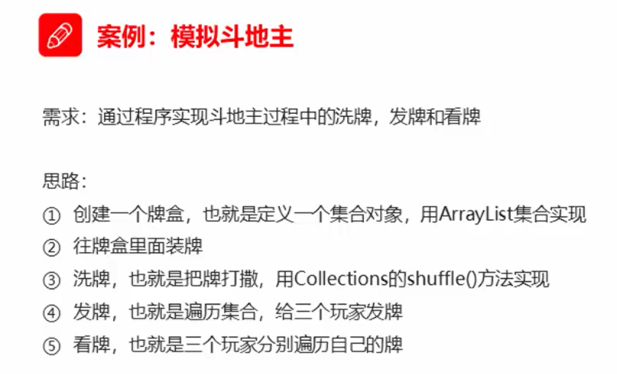

public class Demo {

public static void main(String[] args) {

ArrayList<String> array = new ArrayList<String>();

String[] colors = {"♦", "♣", "♥", "♠"};

String[] numbers = {"2", "3", "4", "5", "6", "7", "8", "9", "10", "J", "Q", "K", "A"};

for (String color : colors) {

for (String number : numbers) {

array.add(color + number);

}

}

array.add("小王");

array.add("大王");

Collections.shuffle(array);

// System.out.println(array);

ArrayList<String> ding = new ArrayList<String>();

ArrayList<String> lin = new ArrayList<String>();

ArrayList<String> ceisten = new ArrayList<String>();

ArrayList<String> dipai = new ArrayList<String>();

for (int i = 0; i < array.size(); i++) {

String poker = array.get(i);

if (i >= array.size() - 3) {

dipai.add(poker);

} else if (i % 3 == 0) {

ding.add(poker);

} else if (i % 3 == 1) {

lin.add(poker);

} else if (i % 3 == 2) {

ceisten.add(poker);

}

}

look("丁总", ding);

look("林总", lin);

look("小陈", ceisten);

look("底牌", dipai);

}

public static void look(String name, ArrayList<String> array) {

System.out.println(name + "的牌是");

for (String poker : array) {

System.out.print(poker + " ");

}

System.out.println();

}

}

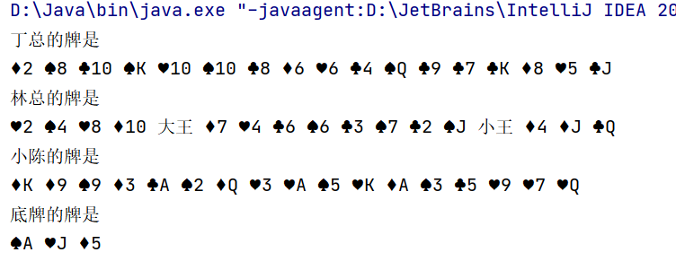

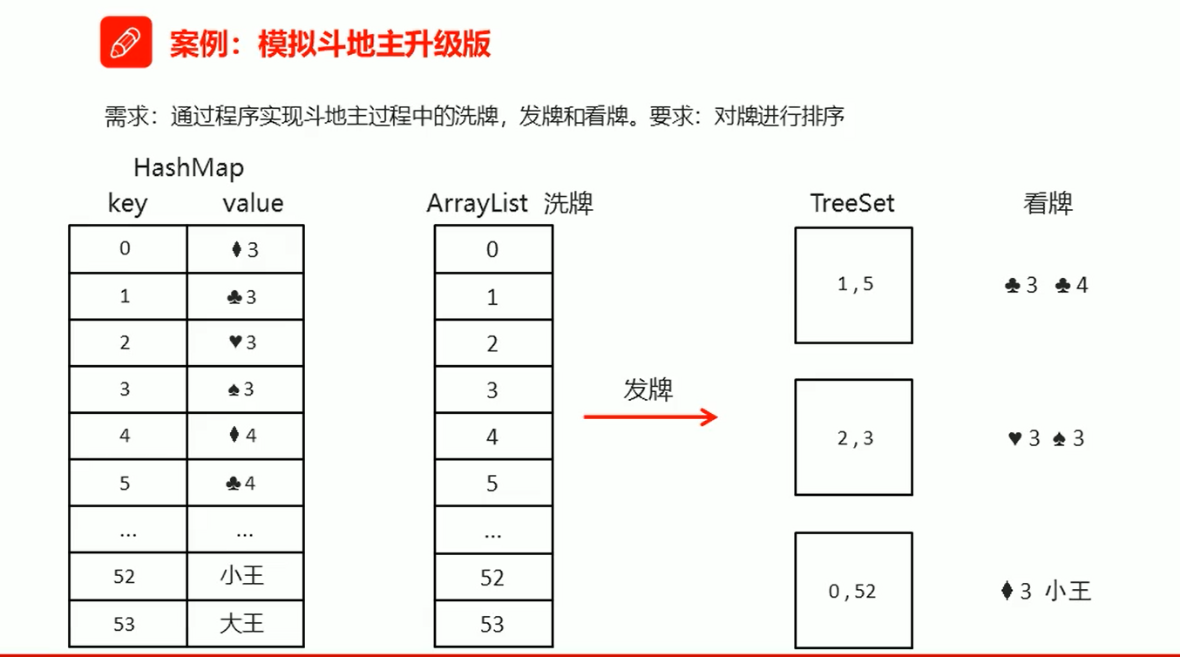

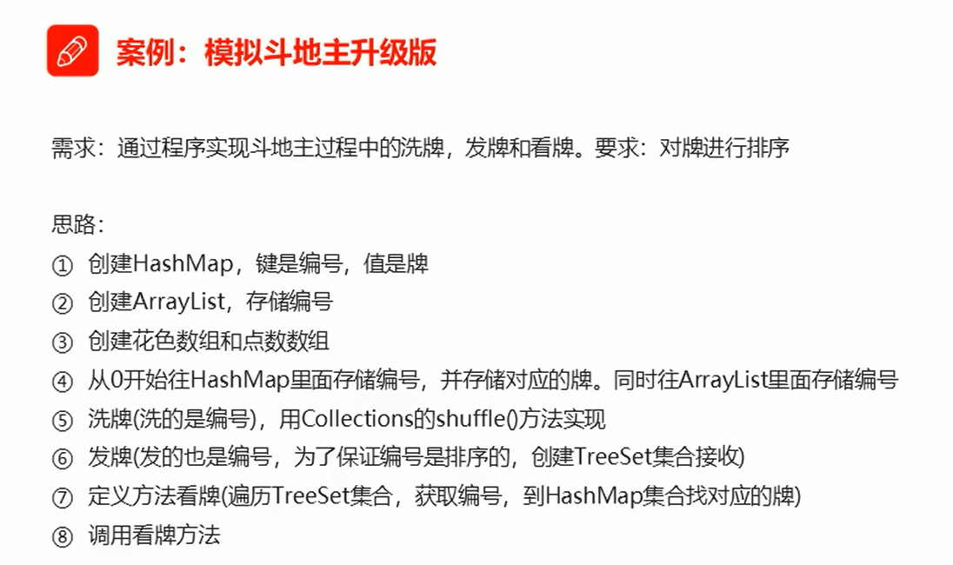

public class Demo {

public static void main(String[] args) {

HashMap<Integer, String> hm = new HashMap<Integer, String>();

ArrayList<Integer> array = new ArrayList<Integer>();

String[] colors = {"♦", "♣", "♥", "♠"};

String[] numbers = {"3", "4", "5", "6", "7", "8", "9", "10", "J", "Q", "K", "A", "2"};

int index = 0;

for (String number : numbers) {

for (String color : colors) {

hm.put(index, color + number);

array.add(index);

index++;

}

}

hm.put(index, "小王");

array.add(index);

index++;

hm.put(index, "大王");

array.add(index);

Collections.shuffle(array);

// System.out.println(array);

TreeSet<Integer> ding = new TreeSet<Integer>();

TreeSet<Integer> lin = new TreeSet<Integer>();

TreeSet<Integer> ceisten = new TreeSet<Integer>();

TreeSet<Integer> dp = new TreeSet<Integer>();

for (int i = 0; i < array.size(); i++) {

int x = array.get(i);

if (i >= array.size() - 3) {

dp.add(x);

} else if (i % 3 == 0) {

ding.add(x);

} else if (i % 3 == 1) {

lin.add(x);

} else if (i % 3 == 2) {

ceisten.add(x);

}

}

look("丁总", ding, hm);

look("林总", lin, hm);

look("小陈", ceisten, hm);

look("底牌", dp, hm);

}

public static void look(String name, TreeSet<Integer> ts, HashMap<Integer, String> hm) {

System.out.println(name + "的牌是");

for (Integer key : ts) {

String poker = hm.get(key);

System.out.print(poker + " ");

}

System.out.println();

}

}

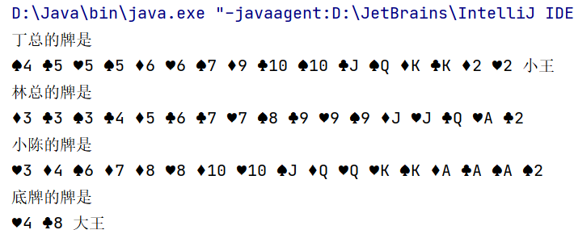

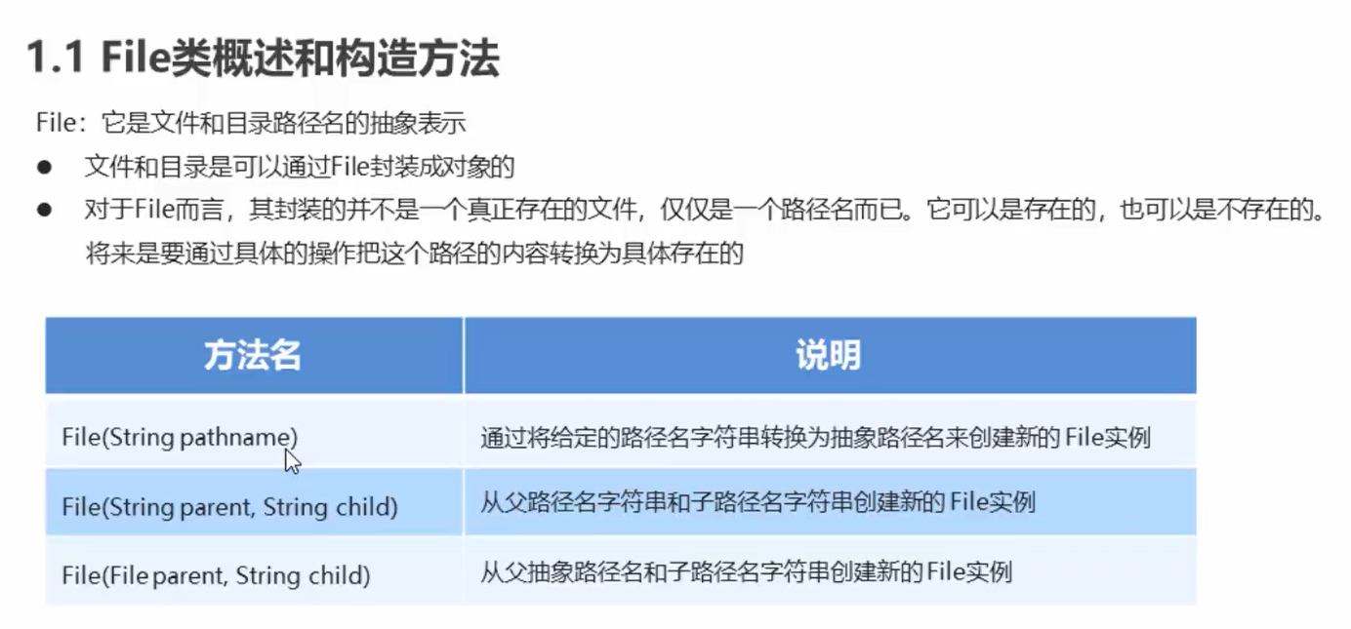

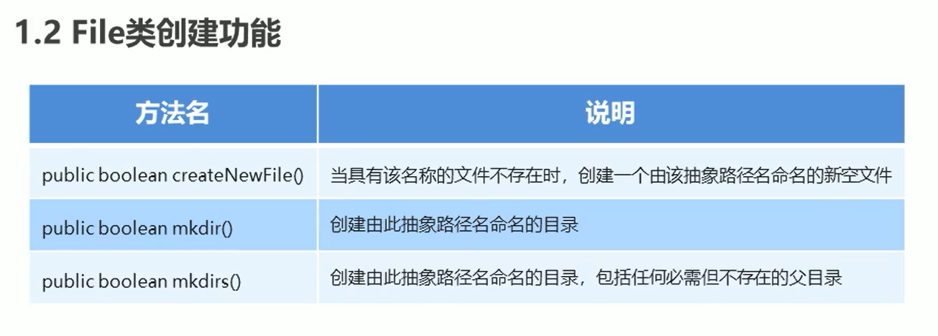

public class Demo {

public static void main(String[] args) throws IOException {

File f1 = new File("D:\\bailan\\java.txt");

System.out.println(f1.createNewFile());

System.out.println("--------------");

File f2 = new File("D:\\bailan\\javeSE");

System.out.println(f2.mkdir());

System.out.println("--------------");

File f3 = new File("D:\\bailan\\javeWeb\\wonendie");

System.out.println(f3.mkdirs());

System.out.println("--------------");

File f4 = new File("D:\\bailan\\javeSE\\ceisten.txt");

System.out.println(f4.createNewFile());

}

}

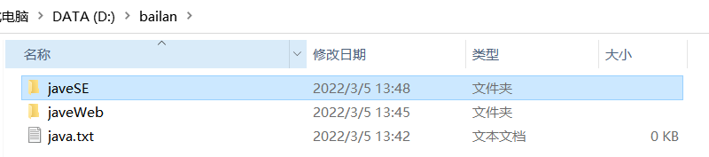

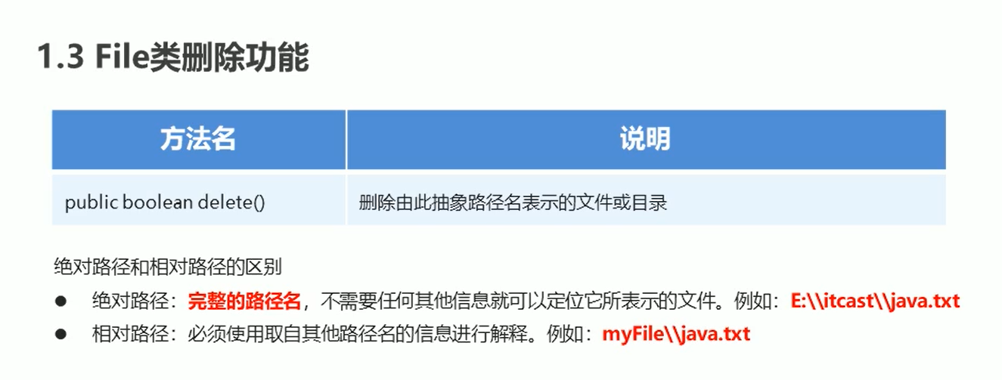

File f1 = new File("600141\\java.txt");

System.out.println(f1.createNewFile());

System.out.println("--------------");

System.out.println(f1.delete());

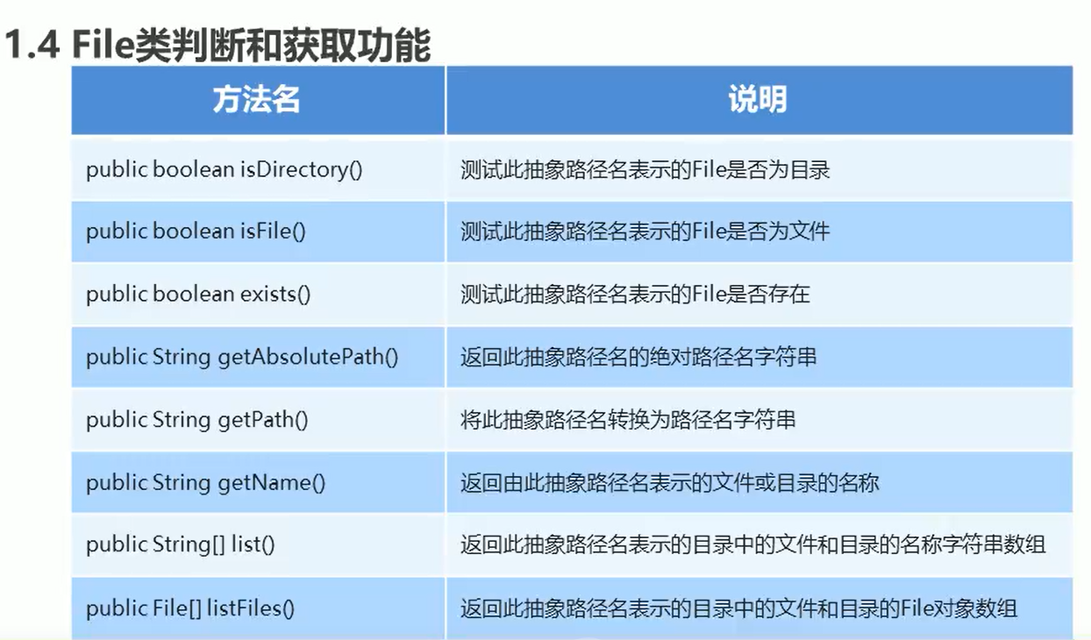

public class Demo {

public static void main(String[] args) throws IOException {

File f1 = new File("600141\\java.txt");

System.out.println(f1.createNewFile());

System.out.println(f1.isDirectory());

System.out.println(f1.isFile());

System.out.println(f1.exists());

System.out.println(f1.getAbsolutePath());

System.out.println(f1.getPath());

System.out.println(f1.getName());

}

}

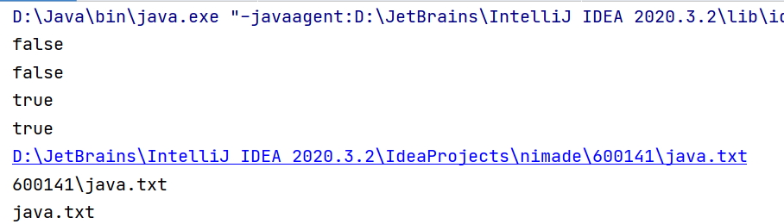

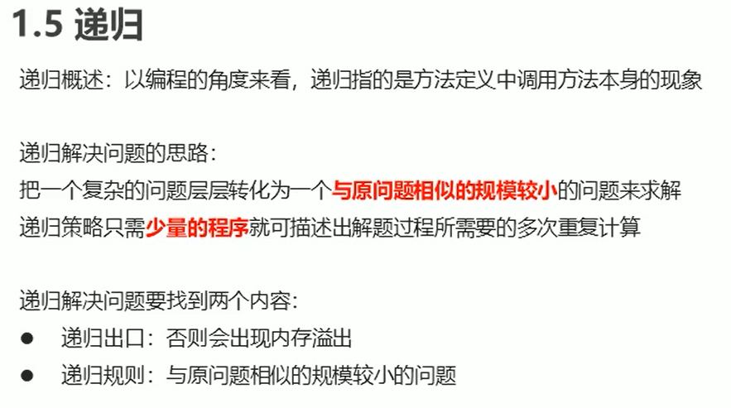

斐波那契数列递归解法

public class Demo {

public static void main(String[] args) {

System.out.println(f(20));

}

public static int f(int n) {

if (n == 1 || n == 2) {

return 1;

} else {

return f(n - 1) + f(n - 2);

}

}

}

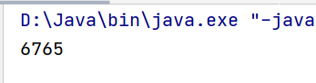

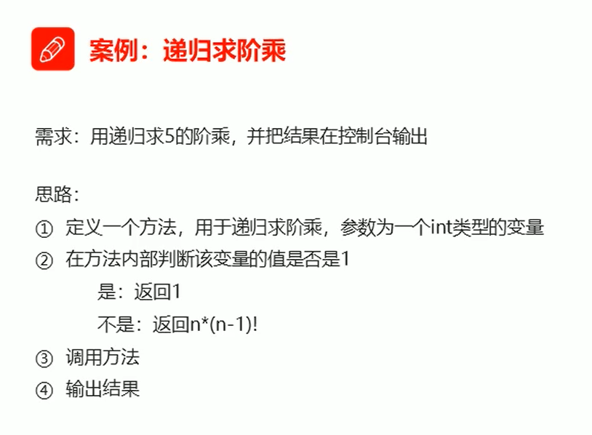

public class Demo {  
 public static void main(String[] args) {  
 System.out.println(jc(5));  
 }  
 public static int jc (int n) {  
 if (n == 1 ) {  
 return 1;  
 } else {  
 return n*jc(n-1);  
 }  
 }  
}

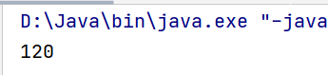

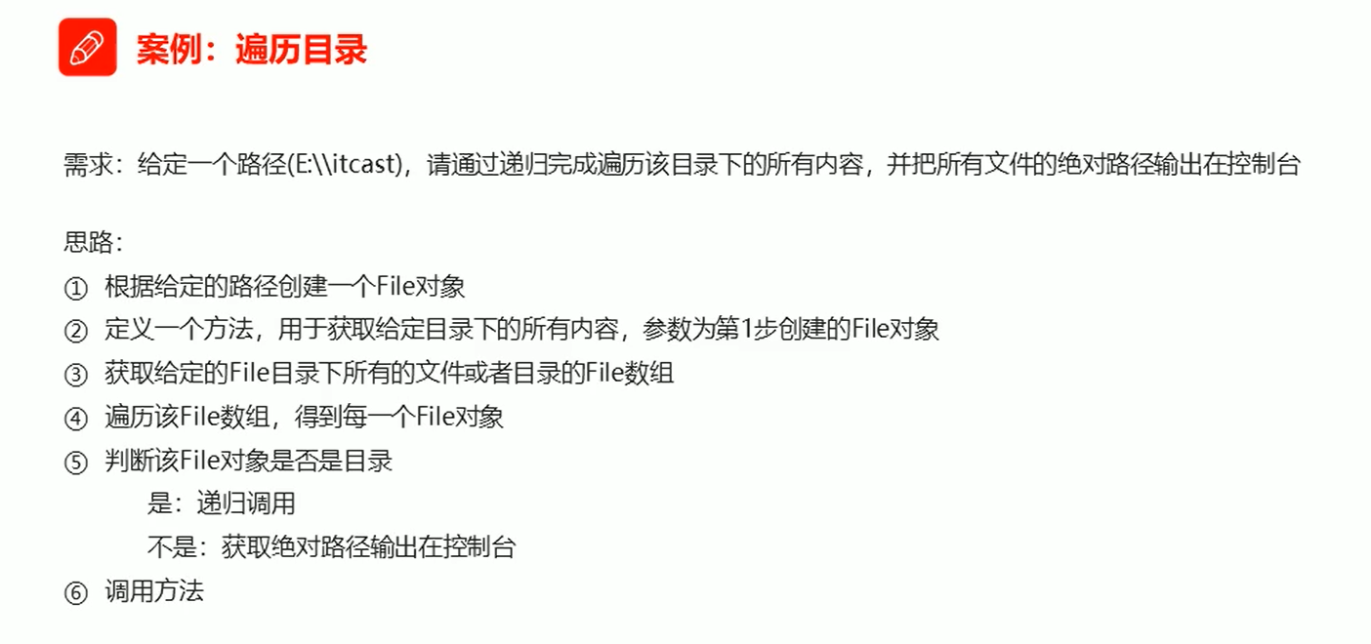

public class Demo {

public static void main(String[] args) {

File BLfile = new File("D:\\研究生\\桥火\\000周记系列");

getAllFilePath(BLfile);

}

public static void getAllFilePath(File BLfile) {

File[] filearray = BLfile.listFiles();

if (filearray != null) {

for (File file : filearray) {

if (file.isDirectory()) {

getAllFilePath(file);

} else {

System.out.println(file.getAbsolutePath());

}

}

}

}

}

